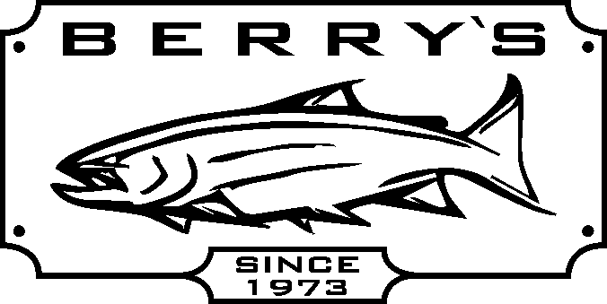
SALTWATER REELS – Great savings on many reels!

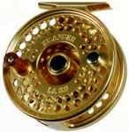
Islander Reels 10 % off all models!

Trophy XL Tyee model mooching reel line cap. 20#/500 yds.
Reg: $ 299.99 SALE: $ 199.99
Trophy XL Tyee QR4.5 large arbor reel line cap.20#/500 yds
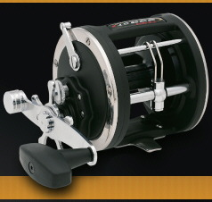
Reg: $ 429.99 SALE: $ 249.99
Daiwa M-one plus - graphite mooching reel line cap. = 20#/520 yds SPECIAL $ 59.99
Shimano 2000 GT – graphite mooching reel line cap. = 20#/340 yds SPECIAL $ 79.99
Shimano 4000 GT – moocher + w/waterproof Dartanium drag Reg $ 129.99 SALE: $ 109.99
Penn 320 GT2 graphite trolling reel, line cap.= 20#/320 yds Reg: $ 169.99 SALE: $ 99.99
Penn 330 GT2 graphite trolling reel, line cap.= 30#/350yds Reg: $ 179.99 SALE: $ 109.99

Quantum Cabo CNW20 PTS – 4 ball bearing 6.1-1 retrieve 65#300yds.braided line Reg$ 299.99 SALE: $ 159.99

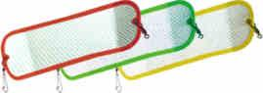
Hot Spot 11” FLASHERS! – ON SALE - Asstd colors $ 2.00 OFF EACH!

SALTWATER COMBOS!
Mooching / Downrigger
Daiwa M-one plus reel + Daiwa WLDR902MHR 9’ rod - 2 piece fiberglass
blank with aluminum oxide guides. Reg: $ 119.99 SALE: $ 79.99
Quantum MCR 3000 reel + Quantum Encore ENC1062 DRT line rated 20-30# Reg: $ 129.99 SALE: $ 89.99
Zebco RNCG 90 DRT 9’Indestructible rod + Daiwa M-one Plus reel Reg: $ 149.99 SALE: $ 109.99

Halibut / Sturgeon
Penn 330GT2 - cap.=30#/300 yds + Penn SL3080C 6 ‘6” rod 30-80# test line Reg : $ 249.99 SALE: $ 169.99
Penn 330GT2 – cap.=30#/300 yds + Shakespeare BWB1140 6’6”rod 20-50 # test Reg: $ 249.99 SALE: $ 179.99
DAIWA Coastal series rods – YOUR CHOICE REG: $ 79.99 SALE: $ 69.99
CLW-SS 1102 MHRB 11’ rod with trigger style handle, 10-20# test rated ½- 1 ½ oz lure
CLW-SS 1062 MHRB 10’6” rod with trigger style handle , 10-20# test rated, ½ - 1 ½ oz lure
CLW-M 1062 M-G 10’6” mooching rod REG: $ 69.99 SALE: $ 49.99

Quantum Coldwater CWC112HC 11’ baitcasting line rated 15-50# REG: $ 109.99 SALE: $ 79.99
Trophy XL – Royale TR580C sturgeon rod 8’ rated 40-80# test REG: $ 179.99 SALE: $ 99.99

***** WE HAVE 10ft, 11ft, 12 ft, and 15ft UGLY STICK SPINNING RODS IN STOCK *****
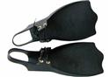
Protac- Sportsman fins fits both - REG: $ 59.99 SALE: $ 34.99!
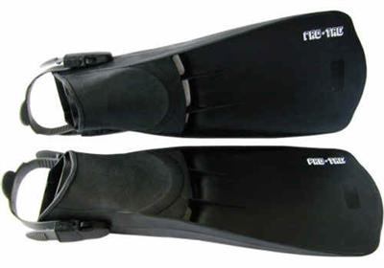
stocking foot & boot foot waders .
Protac- Power fin – REG: $ 69.99 SALE: $ 49.99!
Sedge – 9 ½ foot fly rod and reel case, that holds both your rod & reel

REG: $ 29.99 SALE: $ 19.99!

MANY, MANY MORE IN STORE SPECIALS TOO MANY TO LIST HERE!

AVAILABLE ON-LINE FOR MAIL ORDERS!
(DOOR CRASHERS AND 69 CENT EACH INDIVIDUAL FLIES NOT AVAILABLE FOR MAIL ORDERS)

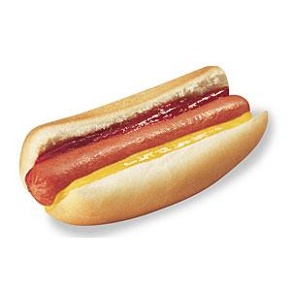
FREE HOT DOGS AND DRINKS SATURDAY AND SUNDAY!

BERRY’S BAIT & TACKLE - SERVING Fisherman for over 37 years!
WWW.BERRYSBAIT.COM EMAIL: SUPPORT@BERRYSBAIT.COM
14651 Westminster Hwy. Richmond. 604-273-5901

