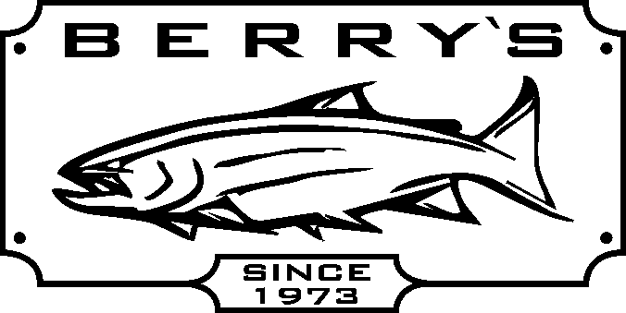
View pictures & sale information online@ WWW.BERRYSBAIT.COM

Many more pontoon boats ON SALE – too many to list here!

DISCOVERY 8 IR – 8’- 6 pc alum. frame, padded seat, anchoring
system & motor mount .- load to 300 lbs.
Suggested at $ 899.99 now only …
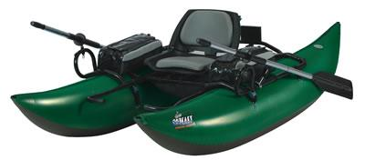
SAVE $200.00!

DISCOVERY 9 IR 9’- 6 pc alum.frame, padded seat, anchoring system,
with motor mount , - load to 400 lbs..
Suggested at $ 1099.99 now only ……

NEW! Fish Cat Wave 9 – entry level pontoon boat 9 ft with oars 10 pc
steel frame - load to 375 lbs. REG: $ 599.99 SALE PRICE: $ 449.99
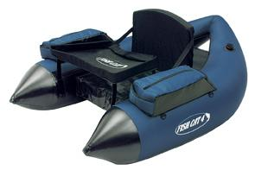
V-BOATS
FISH CAT 4 LCS- with foam seat, load to 250 lbs AIRFLO- Northwest 2 handed Skagit head
Reg: $ 299.99 SALE : $ 189.99 PRICED TO CLEAR! 6/7 or 7/8 only
FISH CAT DELUXE 4 LCS – with inflatable (includes leader wallet & 200 grain tip)
seat and backrest load to 275 lbs REG: $ 79.99 SALE: $39.99
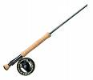
Reg: $ 369.99 SALE : $ 249.99

Dragonfly rod and reel combo Dragonfly graphite fly rods- DFW 9’ #3-9 weights
DFW96 9’ #6 wt rod plus Kamloops cassette with FREE rod bag & cordura covered rod tube
reel DK5/6 Comes with FREE spare Reg: $ 109.99 SALE: $ 79.99!
cassette & rod case. Reg: $ 179.99

Dragonfly Classic Spey Combo
SALE: 13’ graphite 4 pc rod # 8/9 wt Dragonfly
Machined spey reel with counter balanced
spool, gold & silver anodizing w/ FREE rod case Reg : $ 699.99

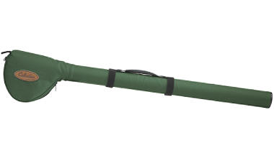
FENWICK HMX 905 9’#5 fly rod FENWICK fly rod/reel combo – HMXF906 9’ #6 wt
With FREE rod and reel case! fly rod + disc drag reel, fly line, & cordura covered fly
Reg: $ 159.99 SALE: $ 99.99! rod/reel case. Sug $ 359.99 SALE: $199.99!

Daiwa Shock 2000Bi reel+ DSCG 602 Quantum – Exos Trout combo- SS662MA
MLFS 6’rod - reel cap.= 8#/110yds. 6 ½’ rod + Exos 40 reel.cap.= 10#/230yds
Reg: $ 49.99 SALE: $ 34.99! Reg: $ 44.99 SALE: $ 29.99
Quantum 9’ spinning combo SFS902 MH - line Daiwa DSC301B + DSF702M 7’ rod - line
rated 15-40# test + Olympus OL80F cap= 25#/245yds rated 6-14# test reel capacity = 10# 200 yds
Reg: $ 99.99 SALE: $ 59.99 Reg $ 49.99 SALE: $ 29.99
Fenwick Methods CMST 1062M 10’6” rod with Abu BCX 6000 4 ball bearing level wind reel + FREE line
(190 yards of 20# test pre-selected) Reg: $ 261.99 SALE: $ 159.99! SAVE: $ 100.00!
Quantum Classic levelwind reel 1430 or 1431(left) 1pc al. frame 4 stainless bearings, line cap 20#/ 175YDS
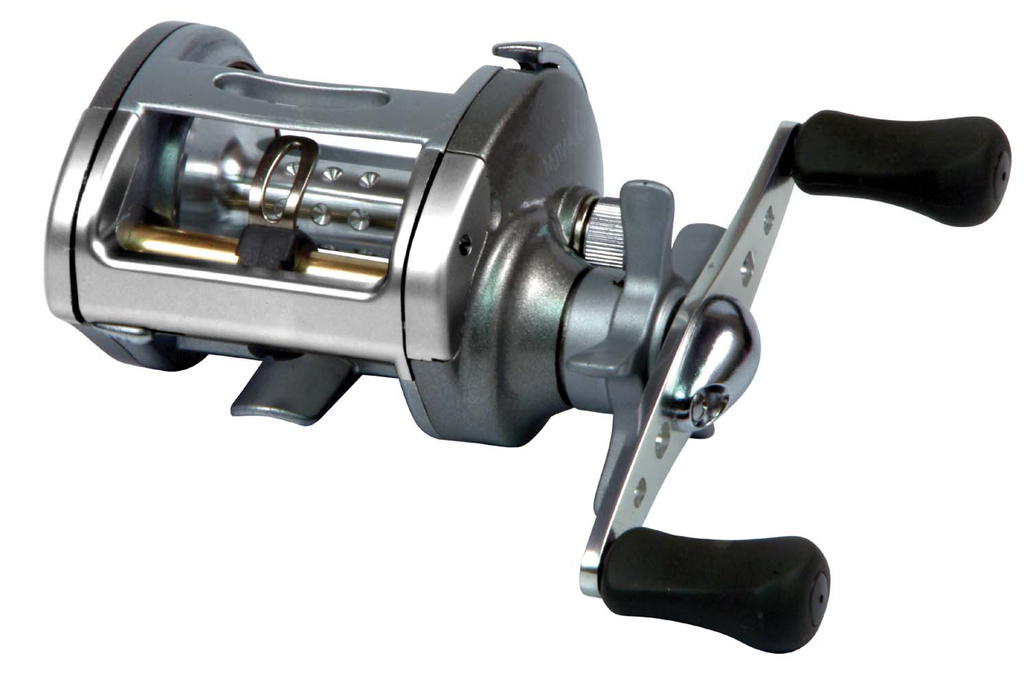
Reg: $ 149.99 SALE: $ 109.99
Quantum Cabo CBC 30 PTS/ CBC 31PTS (left) Quantum Energy Spinning reel 30 PTi-A
6 ball bearing levelwind reel line cap=14#/270yds. 10 ball bearings line cap= 8#/160 yds.
Reg: $ 279.99 BLOW OUT! $ 149.99! REG: $ 259.99 BLOW OUT! $ 129.99

