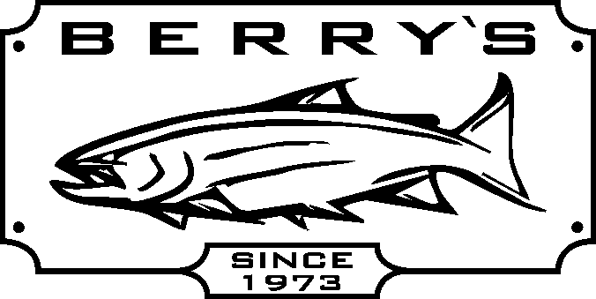
ENJOY FREE HOT DOGS AND DRINKS

SAT. APRIL 10 & SUN. APRIL 11

Most items available for mail orders WWW.BERRYSBAIT.COM
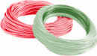

** FISHING LINES- MAXIMA, SEAGAR ** ALL FISHING LURES! **
BERKLEY, TUF, TUF+, P-LINE POWER PRO.. GIBBS, LUHR JENSEN, RHYS DAVIS, TOMIC,
(EXCLUDES BULK SPOOLED ON TO REELS) BUZZ BOMBS, ZZINGERS, APEX, MEPPS,
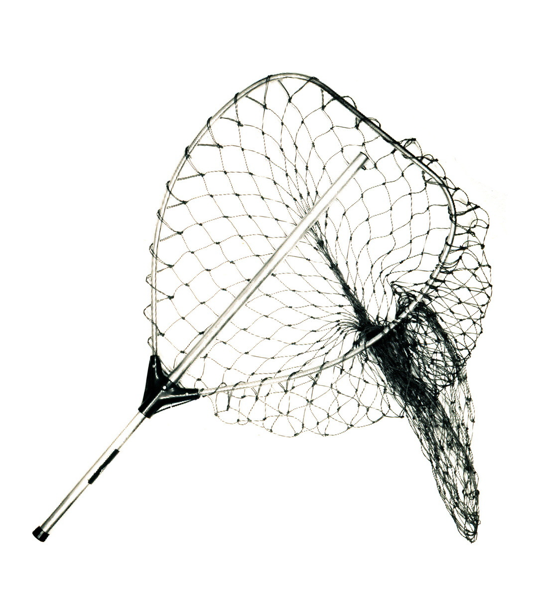
** SELECTED SCOTTY ACCESSORIES BAITRIX … THE LIST GOES ON & ON….
(EXCLUDES ROD HOLDERS & MOUNTS) ** WILLIAM JOSEPH PRODUCTS!
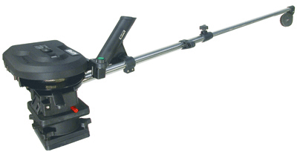
** DISC. SAGE RODS! ** FLY LINES SCIENTIFIC ANGLER,
** BUCK KNIVES CORTLAND, RIO, AIR FLO, & SEDGE.
** HOOKS – ALL TYPES! COLUMBIA CLOTHING
Scotty 1101- 30”electric ** NETS & SCOTTY ROD HOLDERS & MOUNTS
Downrigger w/swivel mount ** FLY TYING MATERIALS & TOOLS.
Sug: $ 799.99 SALE: $449.99 ** FLY BOXES & SA & AIR FLO LEADERS.

Scotty 1106- 60”electric downrigger w/swivel base Sug: $ 799.99 SALE: $ 459.99
Scotty 1080- 24” boom manual downrigger Sug: $ 359.99 SALE: $ 209.99

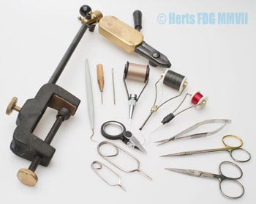
FLY REELS – GREAT DEALS!
Dragonfly- Kamloops cassette fly reel DK56 Reg: $ 69.99 SALE: $ 44.99
comes with free spare cassette.
Dragonfly DX56 LA 5/6 large arbor fly reel Reg: $ 69.99 SALE: $ 49.99
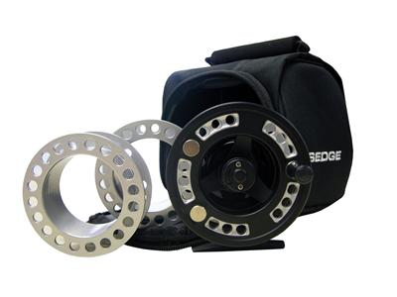
Sedge disc drag fly reels – PTSF5/6 or PTSF7/8 –
comes with 3 spare cassettes and reel case.
Reg: $ 109.99 SALE PRICE $79.99
Dragonfly Kamloops fly reel- made of T6106 bar stock Scientific Angler fly combo – 9 ft #5
aerospace grade machined aluminum, with Japanese one way fly rod + Coachman DV5/6 reel
pin roller bearings (disc drag) MC5/6 Reg: $ 164.99 SALE: $ 129.99 REG: $ 139.99
MC7/8 Reg: $ 177.99 SALE: $ 139.99 SALE: $ 59.99
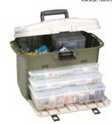
Pflueger Trion forged, machined & anodized Flambeau Tackle system #8010 – comes
aluminum body with center disc drag system with 3 large and 2 small tuff tainer boxes
REG: PRICE $ 169.99 & a huge top storage compartment .
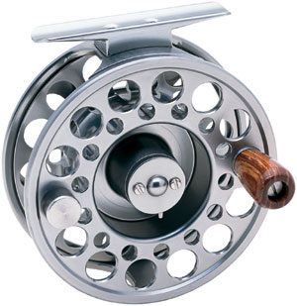
Trion 1934 - 3/4 wt Reg: $ 79.99
Trion 1956 – 5/6 wt SALE:
Trion 1978 – 7/8 wt BINGO BUGS ARE BACK!
Trion 1190 – 9/10 wt We now have stock and they are
Used Molds- Hot pricing
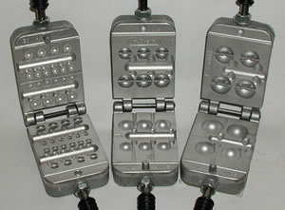
SAVE: $40.00
We stock spare
spools too!

