JUNE 2009
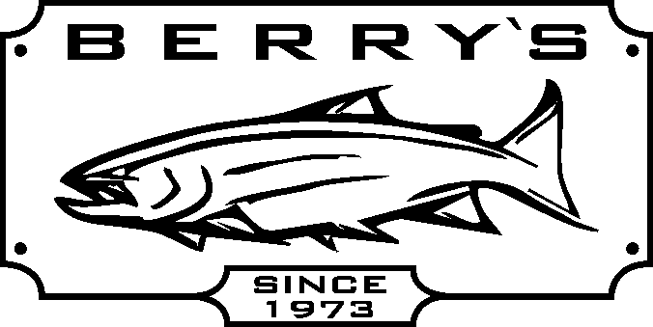
SALTWATER REELS – Great savings on many reels!

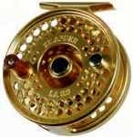
Islander Reels, Sage & Loomis rods 10 % off!

Trophy XL Tyee model mooching reel cap. 20#/500 yds
Reg: $ 299.99 SALE: $ 199.99
Trophy XL Tyee QR4.5 large arbor reel cap.20#/500 yds
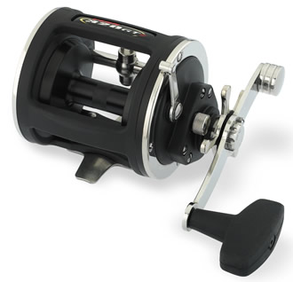
Reg: $ 429.99 SALE: $ 249.99

Daiwa M-one plus - graphite mooching reel line cap. 20#/520 yds SPECIAL $ 59.99
Shimano 2000 GT – graphite mooching reel line cap. 20#/340 yds SPECIAL $ 79.99
Penn 320 GT2 graphite trolling reel, line cap 20#/320 yds Reg: $ 169.99 SALE: $ 99.99
Penn 330 GT2 graphite trolling reel, line cap 30#/350yds Reg: $ 179.99 SALE: $ 109.99

SALTWATER COMBOS!
Daiwa M-one plus reel + Daiwa DR902MHR 9’ rod - 2 piece fiberglass blank, Reg: $ 119.99 SALE: $ 79.99
with aluminum oxide guides.
Quantum MCR 3000 reel + Quantum Encore ENC1062 DRT line rated 20-30# Reg: $ 129.99 SALE: $ 89.99
Zebco RNCG 90 DRT 9’ indestructible rod + Daiwa M-one + reel Reg: $ 149.99 SALE: $ 99.99
Halibut / Sturgeon
Penn 330GT2 - cap.=30#/300 yds + Penn SL3080C 6 ‘6” rod 30-80# test line Reg : $ 249.99 SALE: $ 169.99
P Penn 330 GT2 – cap.=30#/300 yds + Shakespeare BWB1140 6’6”rod 20-50 # test Reg: $ 249.99 SALE: $ 179.99
Salmon Rods DAIWA Coastal series rods – YOUR CHOICE REG: $ 79.99 SALE: $ 69.99
CLW-SS 1102 MHRB 11’ rod with trigger style handle, 10-20# test rated ½- 1 ½ oz lure
CLW-SS 1062 MHRB 10’6” rod with trigger style handle , 10-20# test rated, ½ - 1 ½ oz lure
CLW-M 1062 M-G 10’6” mooching rod REG: $ 69.99 SALE: $ 49.99

TROPHY XL – Royale TR580C sturgeon rod 8’ 40-80# test REG: $ 179.99 Awesome DEAL $ 99.99
* **** WE HAVE 10ft, 11ft, 12 ft, and 15ft UGLY STICK SPINNING RODS IN STOCK *****
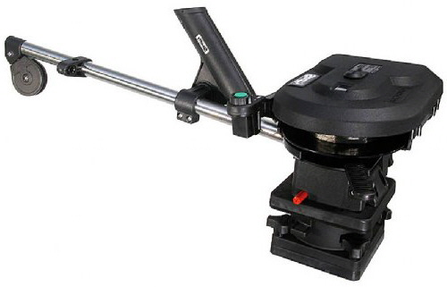
CRAB TRAPS- rubberized folding Scotty 1101 electric downrigger 30”boom
Reg $ 24.99 SALE! $ 14.99 w/pedestal mount SALE: $429.99
Scotty 1106 electric downrigger 60” boom
EVENTS w/pedestal mount SALE: $ 459.99
Saturday June 20th only – FREE ! Scotty downrigger repair clinic – bring your riggers in for a tune up!
(excludes arms and some other items)

JUNE 19 & 20 - is FAMILY FISHING WEEKEND! No licence is required for freshwater fishing. Take your family fishing! - come out to our Family Fishing event SAT.ONLY 10 AM TO 2 PM! LOTS OF PRIZES!

BERRYS’ Customer appreciation FREE hot dogs & drinks Saturday & Sunday!


BRING DAD OUT FOR A FREE LUNCH!

MOST ITEMS AVAILABLE ON-LINE FOR MAIL ORDERS!

MANY, MORE IN STORE SPECIALS TOO MANY TO LIST HERE!

BERRY’S BAIT & TACKLE …
SERVING Fisherman for over 36 years!
WWW.BERRYSBAIT.COM email: berry@berrysbait.com
14651 Westminster Hwy. Richmond. 604-273-5901

