JUNE 2009
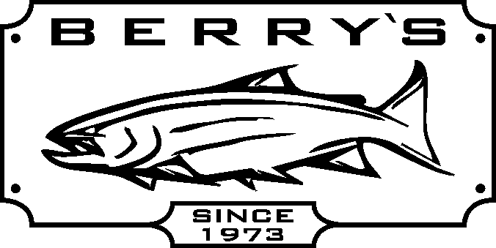
Buy any OUTCAST pontoon boat & receive a seat saddle bag
FREE! Value: $43.99 - view boats online for more sale prices at
WWW.BERRYSBAIT.COM

DISCOVERY 10 IR – 10’-12 pc alum.frame, padded seat, 7’oars
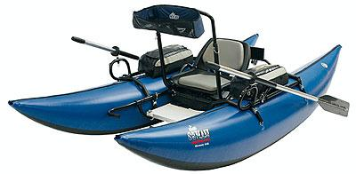
Casting platform / lean bar / stripping apron – load to 450#
Sug: at $ 1399.99 now only …

SAVE: $ 500.00!

DISCOVERY 8 IR - 8’-6 pc alum. frame, padded seat, load to 300 #
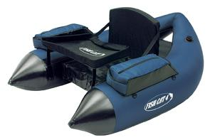
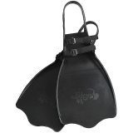
Suggested at $ 999.99 now only … $ 699.99

FINS V-BOATS
Sportsman – fits both FISH CAT 4 LCS- w/ foam seat, load to 250 lbs
stocking foot & bootfoot Reg: $ 299.99 SALE PRICE: $ 189.99
Sug: $59.99 SALE: $ 32.99 FISH CAT DELUXE 4 LCS – with air bladder Powerfin Reg: $69.99 SALE: $ 49.99 for seat, and backrest – load to 275#
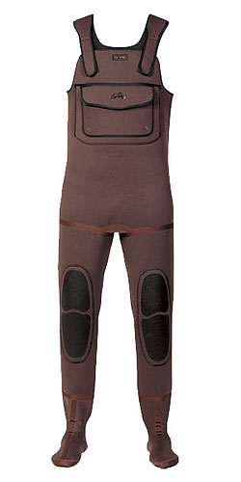
Reg: $ 369.99 SALE PRICE: $ 249.99
BARE WADERS
Sport 3 neoprene NOW $ 89.99 WE NOW STOCK WADERS
Supra 4 neoprene NOW $189.99

1000’s of gift ideas for DAD!
SPINNING COMBOS - many more to see!! www.berrysbait.com
Daiwa DSC-30-3B + DSF 702M 7’medium Quantum Optix 60 combo – OPS 802M 8’med
action rod 6-14# test, reel cap.=10#/200yd action rod 15-30#, reel cap15#/220 yds w/spare spool !
Reg: $ 49.99 SALE: $ 29.99! Reg: $ 59.99 SALE: $ 49.9

Quantum Classic levelwind reel 1430/1431(left) 1pc Berkley Hardrock HS92F-106 10’6” rod + Quantum
A aluminum frame 4 stainless bearings, line cap 20#/ 1430 levelwind reel. Reg: 259.99 SALE: $ 159.99
175 yds Reg: $ 169.99 SALE: $ 119.99 SAVE: $ 100.00! A great casting combo!
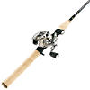
Fenwick Methods CMST 1062M 10’6” rod with Abu SHIMANO Technium baitcasting rod
BCX 6000 4 ball bearing levelwind reel + FREE line TNC-1062 M 10’6” rated 12-20# test
( (190 yards of 20# test pre-selected) Reg: $ 261.99 Reg: $ 169.99
SALE: $ 159.99! SAVE: $ 100.00!
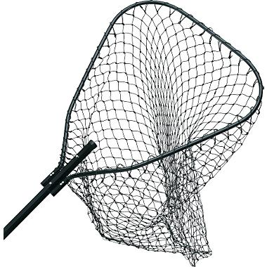
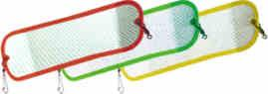
GIBBS salmon net GNP50 Hot Spot 11” FLASHERS!
large size salmon net
Reg: $ 54.99 $ 2.00 OFF EACH!
SALE: $ 39.99
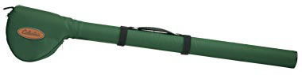
SEDGE – 9 ½ foot fly rod and reel case,
which holds both your rod & reel
REG: $ 29.99 SALE: $ 16.99

