JUNE 2009
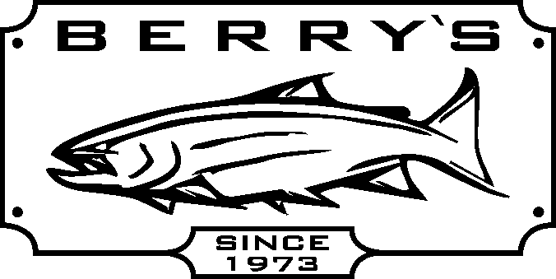
All 0.99 TROUT FLIES on sale at 0.69
(only available for mail orders in 1 dz per size & color for this price)
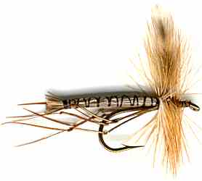
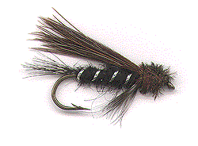
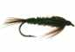
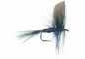

FLY ROD & REEL COMBOS!

Fenwick World Class WCF966-2E 9’6” # 6 wt rod + Blackhawk disc drag
fly reel with FREE floating fly line & Cordura covered fly rod/reel case.
Reg: $ 399.99
SAVE $200.00! SALE
WOW!

Dragonfly Classic 9’ # 5 or # 6 weight fly rod + Dragonfly Kamloops DK5/6 Cassette reel
(comes w/ spare cassette & fly rod case) Reg: $ 179.99 SALE:

Dragonfly Venture DV906 9’ #6 wt fly rod + Angler 5/6 fly
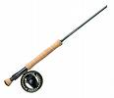
reel Reg: $ 99.99 SALE: $ 49.99 ½ PRICE! AIRFLO –Northwest

Dragonfly Classic 13’ # 8/9 wt. 4 pc Spey rod + 2 handed Skagit Head 6/7, 7/8,
Machined Spey reel with counter balanced spool, gold 9/10 - includes leader wallet &
& silver anodizing w/ FREE rod case - REG: $ 699.99 200 grain tip SALE: $39.99
HUGE SAVINGS…..
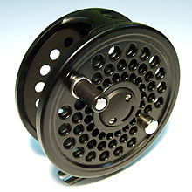
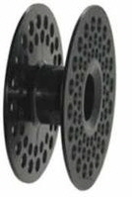
ONLY:

Dragonfly Classic fly rods DFW models 9 ft # 4-9 weights
(comes w/rod sock & cordura covered rod case) REG: $ 109.99
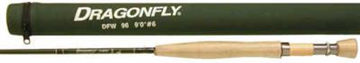
SALE PRICE: $ 79.99
Dragonfly Kamloops Cassette reel DK5/6 SALE: $ 44.99 (Ea reel come with a spare cassette)
Dragonfly Kamloops Cassette reel DK7/8 SALE: $ 54.99

Pflueger Trion reels - forged, machined & anodized aluminum body w/ center disc drag system
REGULARLY PRICED $ 169.99 SUPER SAVINGS! SPORT GEAR waterproof fly boxes -
Trion Trion 1934 - 3/4 wt HT501 or HT502 buy 1 at 15% OFF &
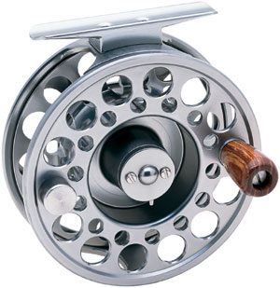
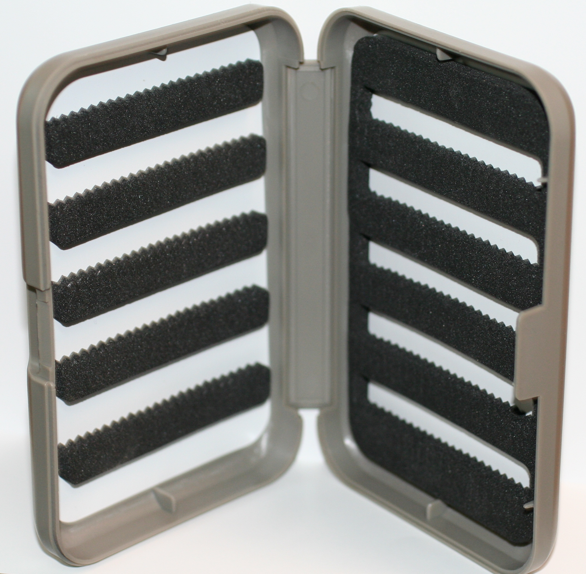
Trion 1956 – 5/6 wt receive HT503 6 slot fly box
Trion 1978 – 7/8 wt FREE !
Trion 1190 – 9/10 wt $ 9.99 value!

Tica Veteran G206R fly reel – aluminum frame & spool, very smooth sealed drag system, comes
with neoprene reel case, reel weight is only 5.6 oz. Reg: $ 79.99 SALE: $64.99 Save $15.00!

