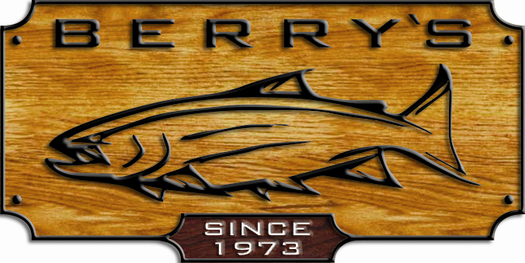
ALL ITEMS AVAILABLE FOR MAIL ORDERS
(EXCLUDING DOOR CRASHERS)

BUY ANY OUTCAST PONTOON BOAT RECEIVE
A SEAT SADDLE BAG FREE! $ 43.99! VALUE

Discovery 10 “IR” new for 08” 12 pc aluminum frame, welded seams, 7 ft oars, casting
Cast platform /lean bar/ stripping apron/450# load cap. Sug: $ 1199.99 Our price: $ 879.99
D Discovery 9 “IR” (aluminum frame) Sug:$ 959.99 Our price: $ 759.99
9 f 9’ pontoons, 6 pc frame, welded seams, load 400 #
Discovery 8 “IR” (aluminum frame) Sug: $ 889.99 Our price: $ 719.99
8 foot pontoons, 6pc frame, welded seams, load to 300 lbs
Streamer XL “IR” 8’entry level, 6 pc frame, load 300 lb. Sug:$ 539.99 Our price: $ 469.99

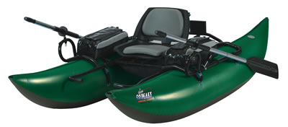
V-BOATS Super Fat Cat Sug: $ 509.99 Our price : $ 319.99
Inflatable seat & backrest, urethane bladder, load 300#
Fish Cat 4 LCS Sug: $ 259.99 Our price: $ 169.99
with foam seat, load 250#
Fish Cat 4 Deluxe LCS Sug: $339.99 Our price: $ 229.99
Accessories with inflatable seat.
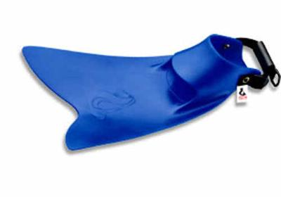
Force fin Reg: $ 149.99 SALE: $ 129.99 Sportsman/ Trophy Fin – fits both
Force fin - Reg: $ 169.99 SALE: $ 139.99 boot foot or stocking foot waders –
adjustable Sug: $ 59.99 Our Sale Price: $ 32.99
Trout rod & reel combos

Daiwa DS-35-3bi , 3 bb reel + DSF 702M 7’ rod Quantum Tempo TS30C reel + TS 662M 6‘6”rod
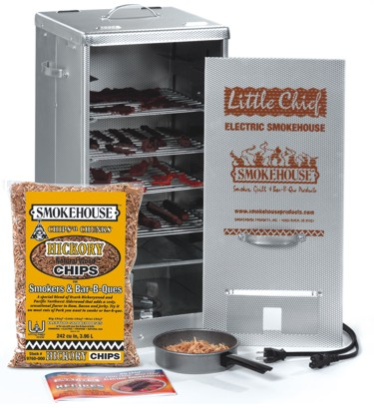
REG: $ 49.99 SALE: $ 29.99 Reg: $39.99 SALE: $ 24.99

Big Big Chief fish/meat smoker Sug: $ 189.99 SALE: $ 119.99
Li Little Chief fish/meat smoker Sug: $ 159.98 SALE: $ 99.99
2 pc fillet knife set reg $24.99 Buy 2 FLATFISH LURES- get 1 extra FREE!
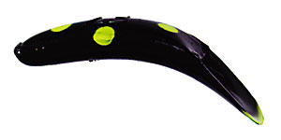
WOW! Only $ 6.99 Buy 2 MUSTAD ITEMS - get 1 extra FREE!

*ALL FISHING LINES- MAXIMA, BERKLEY, TUF,
* P-LINE AND MANY MORE BRANDS (excludes bulk)
* SELECTED SCOTTY ACCESSORIES & BUCK KNIVES


SERVING THE INDUSTRY OVER 36 YEARS!

