CHECK OUT OUR NEW WEBSITE AT WWW.BERRYSBAIT.COM
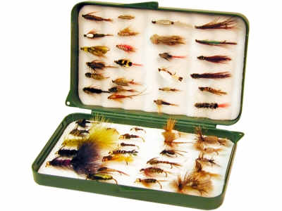
ALL ITEMS ON THIS FLYER ARE AVAILABLE FOR MAIL ORDERS EXCEPT DOOR CRASHERS.

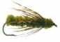
Berry’s HOT DEALS Interior fly selections
on trout flies! fly box with flies ….
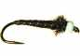

69 12 flies w/ box $19.95
100’s of patterns (reg: 0.99) 24 flies w/ box $ 29.95
Available for mail orders when 50 flies w/ box $ 49.95
ordered 1 dz per size & pattern ( pre-selected )

Omni 9’ fly rod & reel case - Reg: $ 29.99 SALE PRICE: $ 14.99
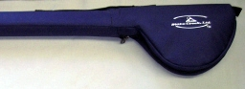
DRAGONFLY graphite fly rods (2pc) on SALE!
FREE cloth rod bag & cordura rod case!
Available in 9 ft # 3 to # 9 weight
7’ spin rod case Reg: $39.99 SALE:$19.99 Reg: $ 109.99 SALE:

ALL fly boxes, fly lines, fly tying materials and tools,
fly leaders, trout nets ,Columbia clothing & vests!
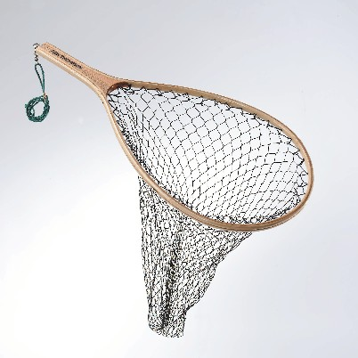
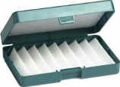
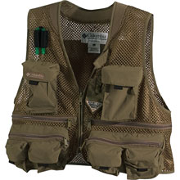
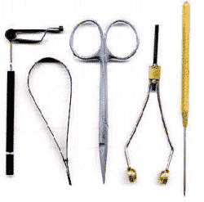


10 % OFF SAGE , LOOMIS AND ISLANDER PRODUCTS !

FLY ROD & REELS COMBOS FLY REELS ON SALE
Dragonfly TS 906-2 rod + Angler 5/6 reel $ 59.99 Dragonfly- fly reel DK56 Reg: $ 69.99 SALE: $ 49.99
Or Dragonfly DFW 905 9’ 5wt + DK56 reel $ 129.99 Dragonfly- fly reel DK78 Reg: $ 69.99 SALE: $ 54.99
Dr Fenwick combo – includes everything Dad needs! Dragonfly DX56 LA 5/6 Reg: $ 56.99 SALE: $ 39.99
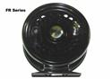
HMXF 9’#6 Fenwick fly rod, Blackhawk disc drag
fly reel, fly line, & cordura covered rod & reel case! Super clear out deals on
REG: $ 359.99 SAVE: $ 160.00! selected Islander fly reels!
ALL FOR ONLY $ 199.99!

