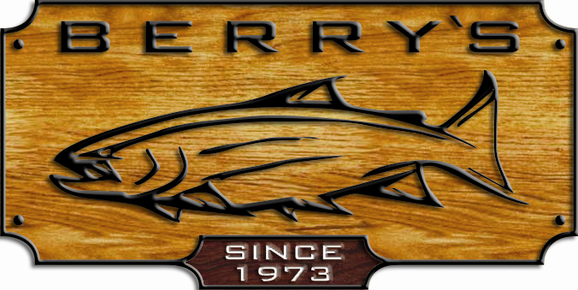
FATHER’S DAY WEEK
SALE !

JUNE 9TH – 15TH

CHECK OUT BERRY’S FAMOUS DOOR CRASHERS!
June 12th-15 ^{th} ONLY, BE ONE OF THE FIRST 10 CUSTOMERS OF THE DAY & RECEIVE
THESE HOT PRICES ON 1 OF 3 OF THE FOLLOWING ITEMS….

ITEM #1 ITEM #2 ITEM # 3

2 SIDED FLY BOX WITH 50 ABU GARCIA 7001 Left hand INLAND CHEST PACK
FLIES, PREMADE - GREAT BAITCASTING REELS PERFECT FOR FLY FISHING
FOR DAD $29.99 ½ PRICE! WOW! $79.99! $ 19.95!
REG: $ 60.00 REG: $ 199.99 (cap =200yd 30#) REG: $ 39.99

LOADS OF GIFT IDEAS FOR DAD!
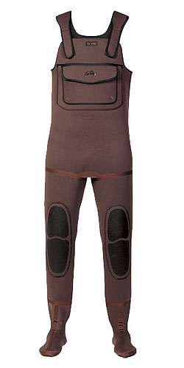
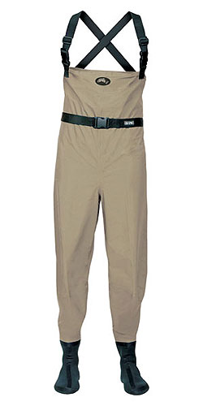
BARE WADERS SECONDS! HUGE SAVINGS!
PLUS INLINE BARE HOT DEALS!
Sport 3 neoprene wader sug: $114.99 HOT DEAL! $ 89.99
Supra 4 neoprene wader sug: $299.99 HOT DEAL! $ 169.99
Cutthroat Breathable wader sug: $269.99 HOT DEAL! $ 199.99
Blackwater Breathable wader sug: $399.99 HOT DEAL! $ 299.99
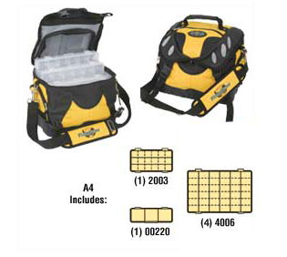
Kodiak Breathable jacket sug: $349.99 HOT DEAL! $ 239.99

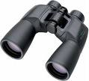
Unex binoculars
FLAMBEAU SOFT SIDED 10x50 with case
TACKLE BOXES only $ 39.99
many styles to choose from!
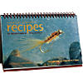
Stillwater Recipes book by
Brian Chan /Phil Rowley
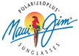
We now stock Maui A great gift idea for Dad!
Jim Sunglasses!
READERS available

