Fraser Valley Salmon Society  in conjunction with the Clark Family, are proud to present the  Greg Clark  Memorial Family  Fishing Derby  The Greg Clark Memorial Family Fishing Derby is sanctioned by the B.C Family Fishing Society and is held on the “Family Fishing Weekend”. NO FISHING LICENCE IS REQUIRED to participate in this event although all other applicable rules and regulations are in effect  LOTS of PRIZES
  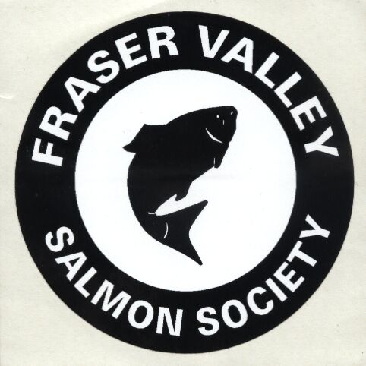  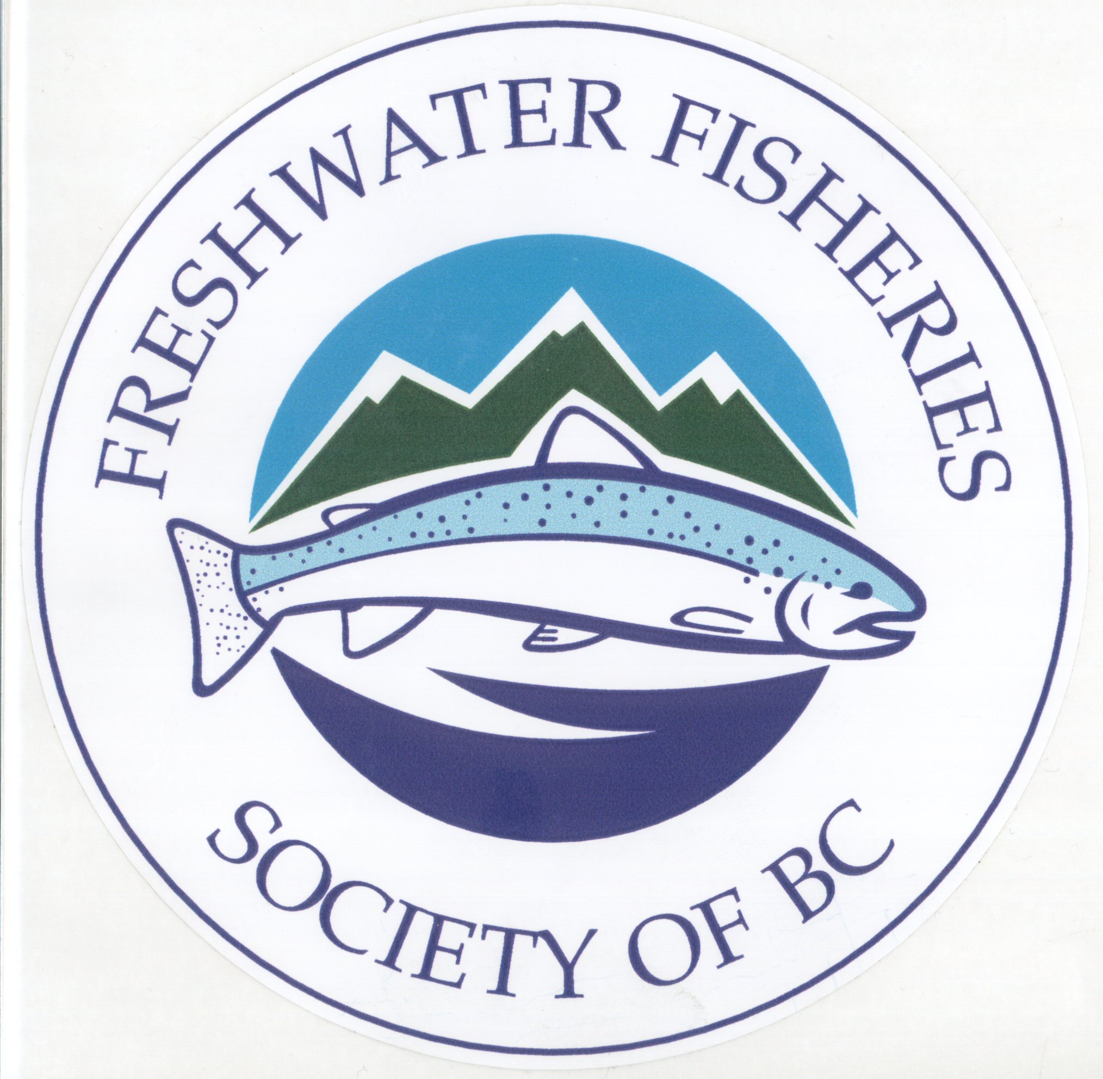 | 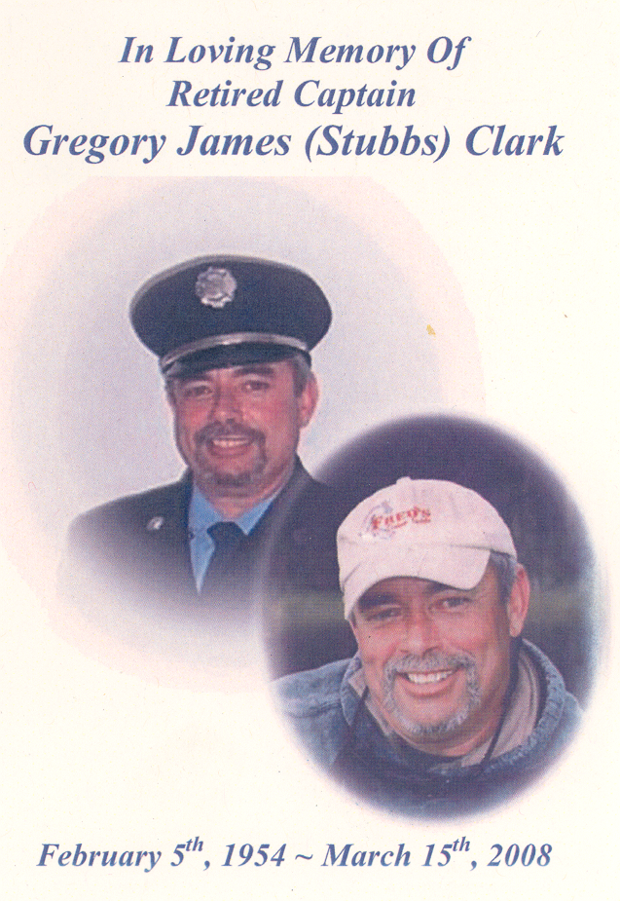 | 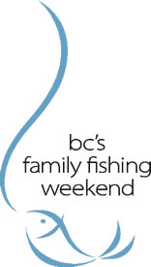
   | Proud Sponsors
  SATURDAY JUNE 14, 2008  MAIN BEACH @ CULTUS LAKE  PIKE MINNOWS ONLY  Derby starts at daybreak…….WEIGH-IN by 2:00 PM sharp!  Prize ceremony starts at 2:30 pm  Memorial Trophy to be awarded to the Largest Junior fish (pike minnow)  Prizes awarded in Adult and Junior categories  All adult and junior ticket holders will be eligible for raffle draw prizes. All prizes must be claimed immediately or forfeited!  TICKETS @ FRED’S CUSTOM TACKLE, CHILLIWACK DART & TACKLE  ADULT (16 and over) $5.00 each  JUNIOR (15 and under) $2.00 each | 
   | 
  Cultus Lake
  Sockeye
  Recovery
  
  Rainbow Country Inn
  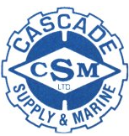
  PRIZES
  VIOLATIONS OF GOOD SPORTSMANSHIP MAY LEAD TO DISQUALIFICATION

