Thompson River Steelhead

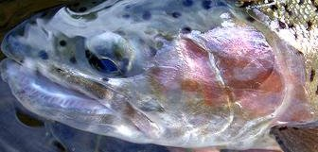

A Path to Recovery

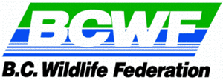

Project Delivery, Coordination
& Workshop Facilitation

Workshops

And

Consultation

Project Management

& Funding Delivery

Report
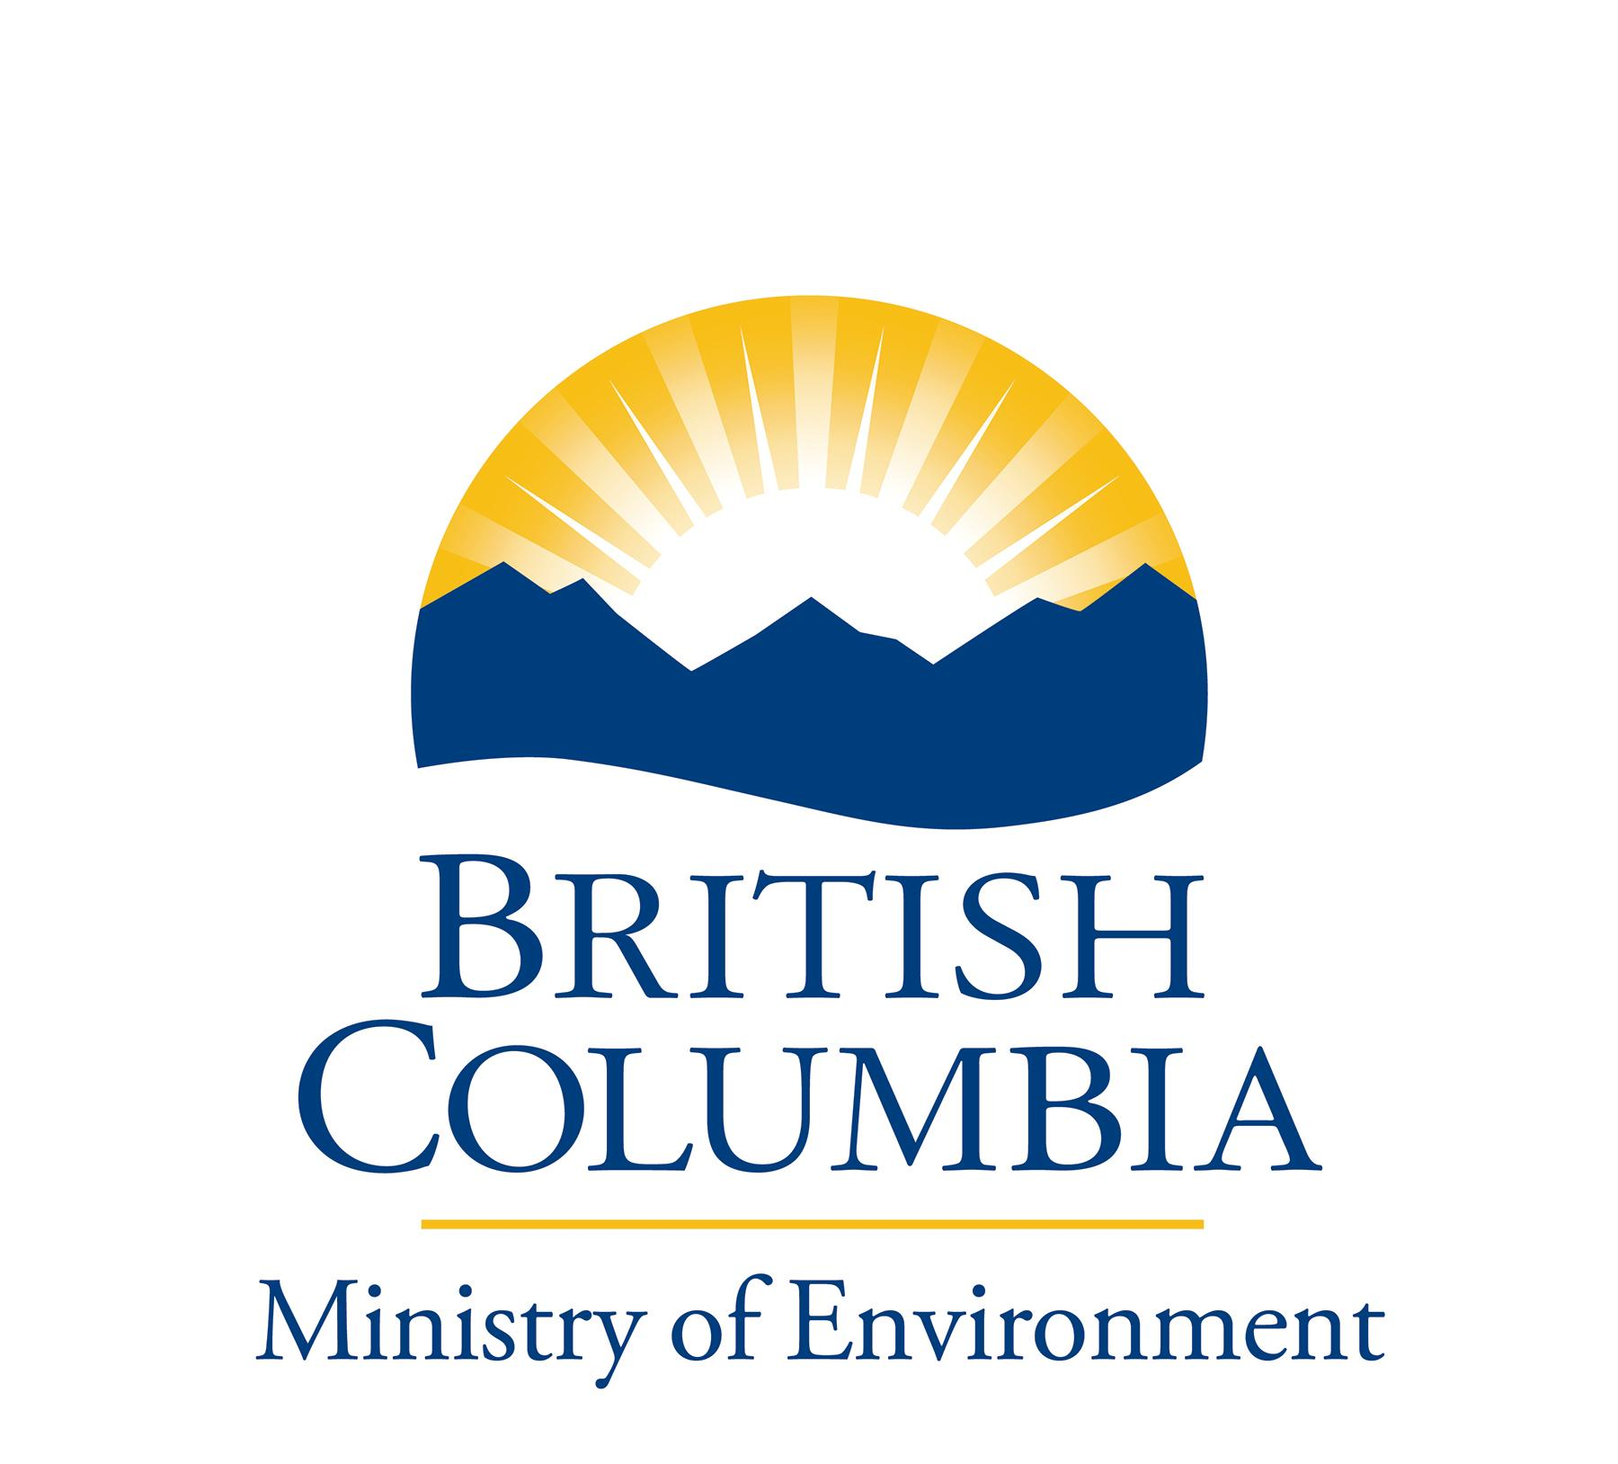

A Living Rivers Trust

Fund Initiative

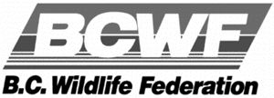

April 15th, 2006

Memorandum to the Reader:

I submit this report on Thompson River Steelhead following a series of three focused workshops and consultation with members of the public, first nations, multiple stakeholder groups and government agencies. The BC Wildlife Federation led this project, in conjunction with the Ministry of Environment and the Pacific Salmon Foundation. The funding was provided by way of a grant to the BC Wildlife Federation from the Living Rivers Trust on the recommendation of the Ministry of the Environment.

Let me personally thank those individuals, independent anglers, commercial fishermen, First Nations representatives, partners, stakeholder organizations, presenters and government agencies that took time to share their knowledge and participate in this consultation process. Additionally, I would like to acknowledge Paul Rickard, Ministry of Environment staff Al Martin, Ian MacGregor, Rob Bison and Al Caverly, the Pacific Salmon Foundation staff Paul Kariya, Al Kenney and Diane Ramage, LGL Ltd., Bob Bocking and the BC Wildlife Federation for their assistance in the success of this project.

During the consultation and workshops, many people provided information in good faith while sharing their personal opinions about current challenges facing Thompson River steelhead. Those opinions, and other estimations contained in this report are not to be construed as accurate or necessarily intended to portray the policies of either federal or provincial government, the BC Wildlife Federation, or the Pacific Salmon Foundation. The material contained herein is intended to provide a sample of public opinion and makes no judgment of how Thompson River steelhead or the Thompson-Nicola watersheds are currently managed.

The information gathered during the consultation and workshops is both practical and important. These public opinions provide valuable perspectives for consideration when government decides how best to manage Thompson River steelhead back to long-term sustainability for all our benefit in the future. I was particularly impressed by the quality of the workshop participant response and believe this consultation report provides some excellent advice from stakeholders and interested members of the public.

Yours in conservation,
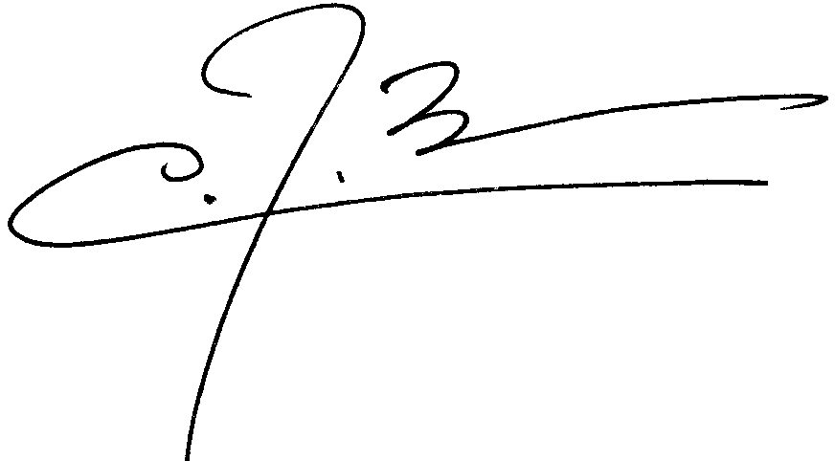

Christopher Bos
Facilitator Coordinator
BC Wildlife Federation
PREFACE

The Thompson River steelhead workshop and consultation project was developed to enable an exchange of information between Fisheries and Oceans Canada (DFO), BC Ministry of Environment (MOE) and the public on stock assessment, harvest management and habitat of Thompson River steelhead. The completion of this consultation process and final report provides a context to government of the public and stakeholder awareness and sentiment regarding the importance of Thompson River steelhead.

This initiative is one part of a multi-component assessment and action program, supported by the Living Rivers Trust Fund, which the provincial government has embarked upon for the Fraser River Basin and Watershed. Working cooperatively with the Ministry of Environment and the Pacific Salmon Foundation, the BC Wildlife Federation welcomed the opportunity to participate in this multi-stakeholder consultation process.

This consultation was based on a fish first approach, and recommendations contained in this report, if adopted, will place a high emphasis on the principle of “healthy fish, means a healthy watershed”, thus providing for an improved quality of life for those who live and work within the bounds of the watershed. Thompson River steelhead will further benefit from other complimenting habitat restoration and water management programs that are being considered or already underway.

As a conservation-based organization, the BC Wildlife Federation recognizes the urgent need to return Thompson River steelhead to population levels that will ensure long-term sustainability as extremely important. This is even more important as changes in climate conditions add greater uncertainty to fish habitat health.

For copies of this report or further information about this project,

Please contact Christopher Bos

By telephone at (250) 652-4141

Or by email at governor@shaw.ca

TABLE OF CONTENTS:

Letter from the Facilitator Coordinator 2

Preface 3

Table of Contents______________________ 4

Introduction 5

Background 6

Consultation Process___________________________________________ 10

Consultation Results____________________________________________ 15

Workshop I - Stock Assessment 15

Workshop II - Increasing Adult Returns 15

Workshop III – Habitat Protection 19

Additional Comments 23

Recommendations 24

Appendices:

Advertising Materials & Invitation List_______ (i)
Workshop Attendance List (ii)
Agenda & Handout Materials for Workshops I, II and III (iii)
Workshop I and II Session Note_____ (iv)
Workshop I and II Plenary Presentations_____________________ (v)
Workshop I and II Breakout Session Notes___________________ (vi)
Workshop III Session Notes_______________________________ (vii)
Workshop III Presentations_______________________________ (viii)
Workshop III Breakout Session Notes_______________________ (ix)
Workshop Minutes and Notes_____________________________ (x)

INTRODUCTION:

Following a successful multi-stakeholder forum lead by the B.C. Wildlife Federation in Spences Bridge on Saturday 18th September 2004, the then Ministry of Water Land and Air Protection committed to continue a proactive partnered approach of building a comprehensive Thompson River Steelhead recovery program.

In April 2005, the Ministry of Water Land and Air Protection, under Minister Bill Barisoff, announced cooperation between the Living Rivers Fund, The Pacific Salmon Foundation and the B.C. Wildlife Federation in the delivery of three linked workshops. These workshops were designed to receive input from the public and stakeholder organizations as well as increase awareness amongst the general public of the drastic decline in Thompson River steelhead. The results of the workshops and consultation will offer guidance to government on the public’s perspective concerning this complex issue.

The British Columbia government is considering the development of a comprehensive recovery initiative for Thompson River Steelhead in advance of stock numbers declining to a level where a Species At Risk Act listing may be forthcoming. As part of this initiative, the BC Wildlife Federation led three workshops addressing the major concerns that Thompson River Steelhead face today and out of these workshops and additional consultations developed recommendations for a recovery planning process.

They were:

Workshop I – Stock Assessment
Workshop II - Increasing Adult Returns
Workshop III - Habitat Protection

In addition to the workshops, discussions and meetings were held between the coordinator and a number of individuals that were unable to attend. Those consultations have also been included in this report. Questionnaires were sent out to invitees to seek additional input. Five were completed and returned with the recommendations being included as well.

At the end of this report is a list of 10 recommendations identified through these collaborative workshops, including the proposed establishment of a Thompson River Round Table with a Steering Committee to lead the recovery planning process.
BACKGROUND:

Geography

The Fraser River is considered one of the world’s greatest salmon resources. Millions of Pacific salmon return annually to spawn in the main stem Fraser River and tributaries such as the Thompson, that includes all five species of salmon, sockeye, pink, chum, chinook, coho plus steelhead. Some salmon, which migrate upriver to spawn in northern tributaries, swim as far as 1000 miles from the ocean to the gravel beds where they were born to complete their life cycle.
A enormous number of juvenile salmon migrate along the river every year on their way from rearing areas to the Fraser estuary. There can be up to 20 million salmon on any given day in the estuary. More than 60 other kinds of fish also use the Fraser River including the mighty sturgeon.
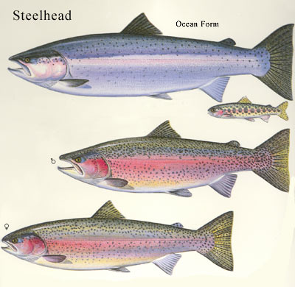
The Thompson River, tributary to the Fraser and one of British Columbia's most important rivers, is home to many species of game fish, including salmon and steelhead, rainbow trout, dolly varden, and mountain whitefish. It is the freshwater home to some of the largest and strongest steelhead found in North America. Figure 2 shows the distribution of steelhead throughout the Fraser drainage.
Named by Simon Fraser after the Northwest Trading Company's explorer and topographer David Thompson, the Thompson is huge with a drainage area of more than fifty thousand square kilometres.

The Thompson River is formed near the city of Kamloops, by the joining of the North and South Thompson Rivers and flows down stream where it joins the main stem of the Fraser at Lytton. This High Country region of B.C. is rich in history as well as recreational opportunities. Tributaries that flow into the North and South Thompson watershed are key Thompson steelhead habitat.
Figure: 1 - Steelhead form (unknown)

Thompson River Steelhead

Within the Fraser River drainage, there are four major stock groupings of steelhead populations: 1) Middle Fraser summer, 2) Fraser Canyon summer, 3) Lower Fraser summer, and 4) Lower Fraser winter (Living Rivers Business Plan). Thompson River steelhead are part of the Middle Fraser summer stock grouping and are considered a conservation concern by MOE (http://www.env.gov.bc.ca/soerpt/4fish/steelhead.html).
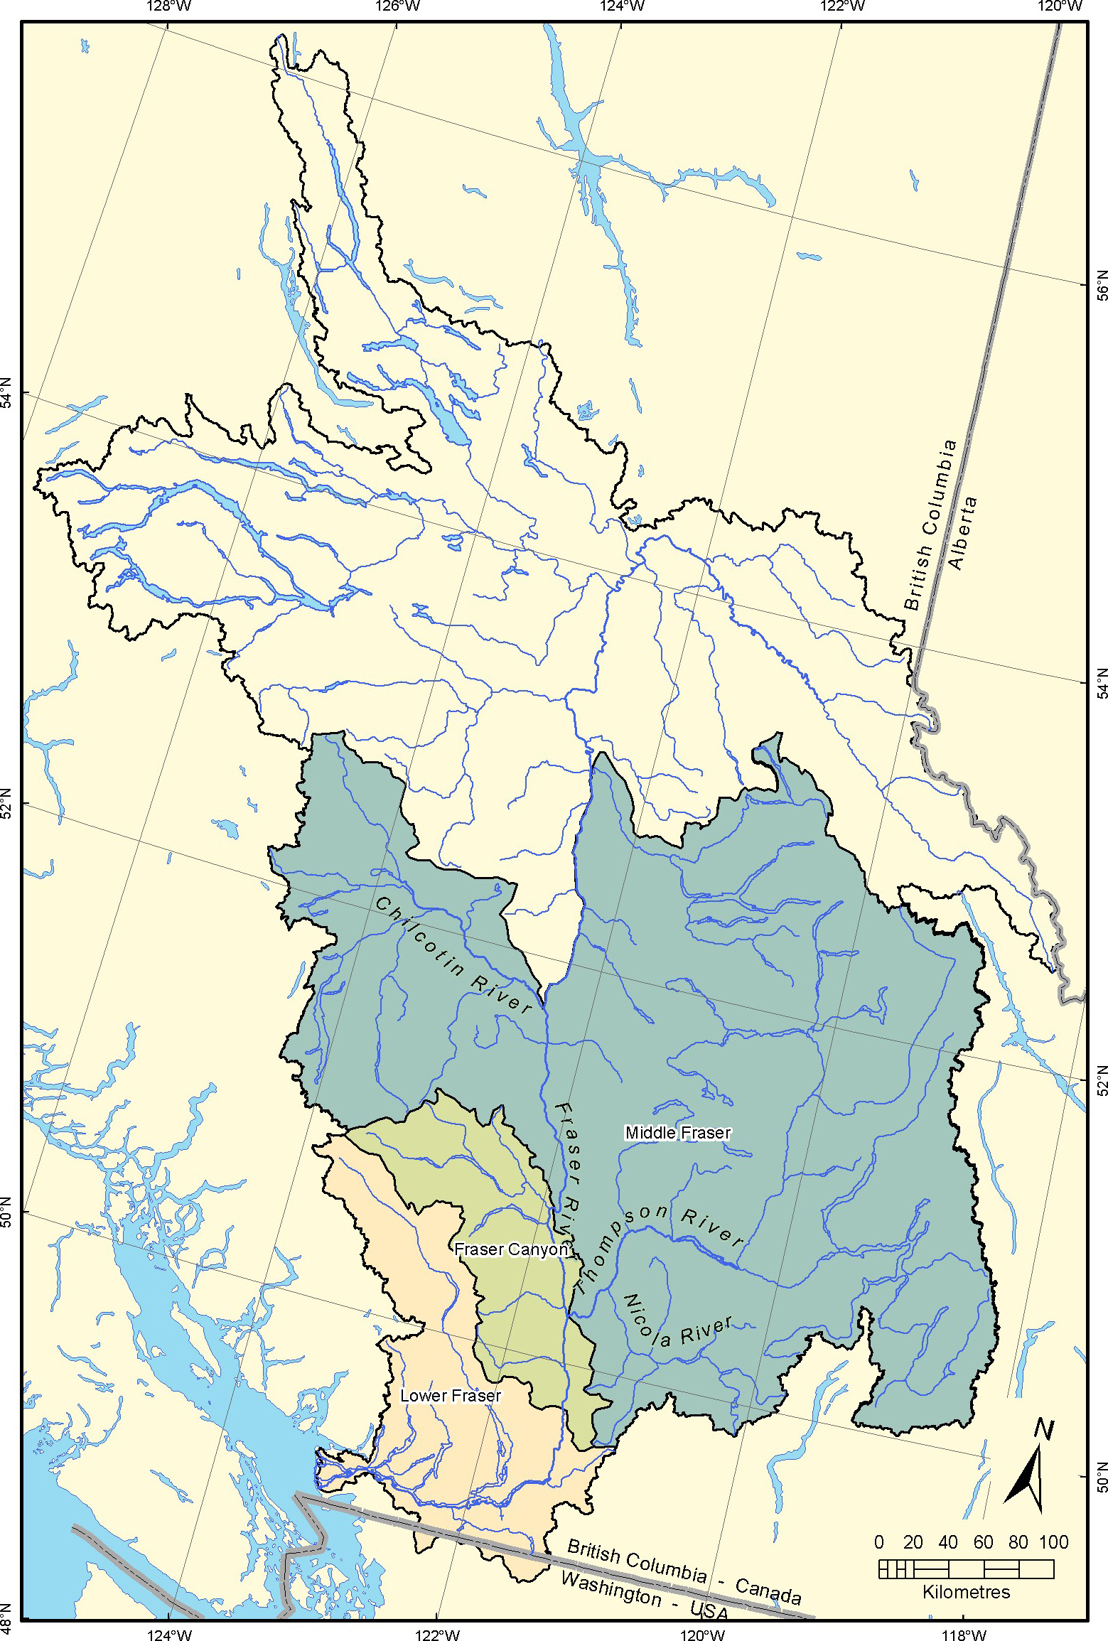

Figure: 2 - Distribution of steelhead in the Fraser drainage (Living Rivers Business Plan)

Thompson River steelhead are internationally acclaimed as the largest and strongest steelhead species in North America. They are regarded as the zenith of salmonid river angling in B.C. Many of B.C.’s steelhead are, at time of spawning, in the range of 8 to 12 pounds in weight. Returning from the ocean in prime condition steelhead in British Columbia are a highly desirable quarry amongst angling purists.

However, the reason that Thompson River Steelhead are so highly revered is because these fish will often reach a weight of twenty pounds and it is not unknown to catch fish in the mid-twenty pound range. They are also equated with a tenacious fighting capability that pits all the skill and determination of the angler against this illustrious game fish.

This uniqueness, along with the freshwater requirements of Thompson steelhead make them an indicator species of the Thompson watershed’s overall health. In recent history Thompson steelhead have been in steep decline and steps need to be taken to protect their habitat and return them to more sustainable levels.

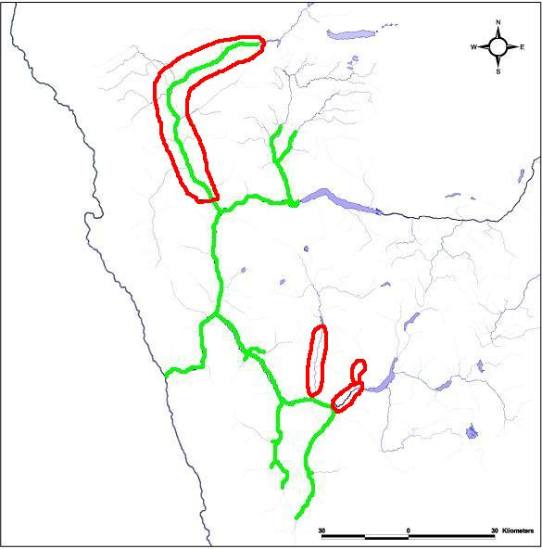
1980’s additional habitat added in Bonaparte
Lost habitat
- diversion, altered flows

Figure: 3 - Current steelhead range in the Thompson drainage (Al Caverly)
Today’s Challenges

Historic (anecdotal) information indicates that returns of adult Thompson River Steelhead could have be as high a 25,000 fish (some claims have been made as high as 40,000). There is, however, empirical evidence of returns of 10,000 adults in the 1960’s. Returns from 1993 to 2005 have ranged from under 1,000 to under 5,000. This is a significant drop in abundance, calling into question whether there are sufficient numbers to maintain this species at long-term healthy levels. Today’s adult returns are low enough to have resulted in Thompson River steelhead being given the status of conservation concern. If and when Thompson Steelhead returns drop below 850 in one year, the designation of “extreme conservation concern” status occurs, requiring even more restrictive management measures.

Problems related to low abundance are rooted in habitat loss, climate change, marine survival challenges, as well as bycatch in commercial fisheries both in-river and in the open ocean. These issues are coincidentally emerging as significant concerns for other Pacific Salmon species.

It is becoming accepted within the science community that we are entering a global climate phase of warming that creates unique stresses on the health and well being of fish in general. This warming trend adds extra pressures on critical fish habitat in both marine and freshwater. Reduced winter snow pack in the watershed combined with less spring/summer precipitation leads to less water storage to maintain river flows and higher in river temperatures which reduces survival rates of steelhead in freshwater. In the marine environment, as the north Pacific warms, warm water species move northward into salmon and steelhead marine areas of residence resulting in increased predation. Warmer ocean temperatures also result in reduced forage success for salmonids.

The human generated effects of agriculture, industry and urban development in the Thompson and Fraser watersheds further compounds these climatic strains. The aggregate result of all these pressures combined has the effect of “death by a thousand cuts”. The single largest issue related to freshwater habitat is water in the Thompson River system. Temperature and annual flow reductions are significant factors in the ability of steelhead and other species of salmon to maintain high levels of productivity.

The need for a cooperative concerted effort to ensure the long-term sustainability of Thompson River Steelhead has never been so great. These fish are at a critical point. If no decisive action is taken before long these world-renowned game fish could well slip to population levels where strict and restrictive government legislation to protect them (The Species at Risk Act) will be triggered. It should be our combined duty to proactively develop a process where the sustainability of the Thompson’s steelhead is given high priority, especially with the additional effects of global warming and the challenges related to urban development within the watershed.

THE CONSULTATION PROCESS:

There were three components to the consultative process: 1) pre-workshop meetings and discussions, 2) the workshops, and 3) a questionnaire.

Pre-Workshop Discussions

Prior to the workshops, the coordinator/facilitator contacted stakeholder groups to invite them to the upcoming consultation. Where attendance was not possible, discussions ensued about Thompson Steelhead and the challenges they face. These pre-consultations helped develop themes for the workshop agenda and provided additional stakeholder viewpoints.

While numerous groups have an interest in or are affected by the plight of Thompson River steelhead, the majority interest came from the recreational angling community. To many anglers the chance to fight a huge Thompson Steelhead is a passion. Knowing how the angling community is so committed to Thompson River steelhead and their long-term sustainability, a special information meeting was held in Surrey at the BC Ministry of Water, Land and Air Protection facility on Wednesday June 22nd, 2005 from 10:00 a.m. till 4:00 p.m. to appraise all the major angling NGOs of the nature and reason for the workshops.

Those in attendance were:

Adams, Devona – Fisheries and Oceans Canada
Bech, Poul – Steelhead Society of BC
Bison, Rob – Ministry of Environment
Bos, Christopher – Facilitator Coordinator BCWF
Caverhill, Peter – BC Federation of Fly Fishers
Clapton, Rod – BC Federation of Drift Fishers
Kenney, Al – Pacific Salmon Foundation
Oram, Arnie – Spences Bridge Steelhead Advocates Association
Reid, Roger – Kingfishers Rod and Gun Club
Rosenell, Marvin – Ministry of Environment
Smith, Brian – BC Wildlife Federation
Toth, Tony – Exec Dir BC Wildlife Federation
Wilson, Greg – Ministry of Environment
Wylie, Dave – BC Federation Drift Fishers

This meeting provided attendees with information about the three-linked workshops and consultation initiative plus identified the reasons for the project and what were the objectives. The meeting also offered additional benefits as attendees learnt more about the Living Rivers Trust Fund receiving an additional 14 million dollars, as announced by BC Premier Gordon Campbell, to increase this fund to a new total of 21 million dollars; plus an explanation of how the provincial government is moving toward a process of recovery for Thompson steelhead.

[See Appendix (x) for Angling NGO meeting notes]
Workshop Planning

The promotion of the workshops was accomplished by: contacting stakeholder groups directly, sending out invitations to stakeholders, notifying the entire Nicola Water Use Management Planning group, utilizing electronic mail distribution to notify a broader audience, sending out press releases, posting the information about the workshops on various websites, utilizing the BC Wildlife Federation club mailing system and advertising the workshops in the print media.

[See Appendix (i) to view Advertising Material and Invitation List]

The coordinator identified higher concentrations of public interest concerning Thompson steelhead centred on two major areas, the Lower Mainland and the Spences Bridge, Merritt, Kamloops and North Thompson area. Those who live within the watershed or proximity to it and those who are connected to the resource through angling, commercial fishing and business supported by angling formed the two main demographics.

The timing and location of the workshops were established to offer the opportunity for the public to participate at a time when traveling was not too hazardous due to extreme winter weather commuting conditions.

Although the fall of 2005 was the optimum time to host the workshops, interested anglers’ schedules were full in the fall of 2005 with a significant number of competing consultations (such as Nicola Water Use Management Plan Meetings, Sport Fishing Advisory Board meetings, the Wild Salmon Policy forums, Angler Participation and Fraser Basin Business/Action Plan meetings). Many anglers also choose to go fishing at that time of year. As the angling community would provide a vital part of the workshop input, the time of February and March 2006 offered better timing.

Participation:

[See Appendix (ii) for Workshop Participant List]

Fisheries and Oceans Canada

For the Habitat Protection Workshop in Merritt we had anticipated participation or attendance of either the Kamloops Area Habitat staff or the Wild Salmon Policy team. One Interior Regional area fisheries manager did attend. An invitation was offered to DFO to be a presenter at the Habitat Protection workshop but they were unable to find staff available to present. DFO has requested they by advised of the outcomes from the workshops and consultation plus expressed regret that no one was available on the day.

The Water Stewardship Branch

The Ministry of Environment - Water Use Management Branch (Kamloops area) wanted to participate in the workshop process but expressed that due to an internal restructuring within the branch and staff changes that no one from their office could attend. The branch staff wants to be fully appraised of the activities related to the Thompson Water shed and steelhead. The branch also wanted to meet with other government agencies and stakeholders to build an improved understanding of the complexities of water management in the region. The branch wants to take a roll in the Thompson water issues management.

First Nations

Important First Nations communities were invited to attend all three workshops. One representative attended the Merritt workshop.

Area D and Area E Gill Netters

Although unable to attend the workshops due to a conflict in their own fisheries meetings, the gill-netters representative wanted us to understand clearly they are also very concerned about Thompson steelhead.

The Workshops

The Stock Assessment and Increasing Adult Return workshops were held on the same day, Saturday, February 11th 2006 in Richmond; then on Saturday, March 4th 2006 the Habitat protection workshop took place in Merritt. This format was chosen to allow residence of both the interior of BC and the Lower Mainland to participate while only having to travel extra distance on one occasion to attend all three workshops.

[Workshop Agendas can be found in Appendix (iii)]

The workshop format was structured to provide the attendees a summary of the latest information on each topic prior to engaging in plenary or break out session debates. Guest presenters from the provincial and federal government provided a series of quality presentations on each topic. Following each presentation attendees were able to ask questions to each presenter and were provide with an opportunity to discuss each topic. After the session presentations and question periods had concluded there was an opportunity for the group to ask questions before the breakout sessions began.

Facilitators:

The BC Wildlife Federation utilized two of their members to provide the facilitation. Both Christopher Bos (Fisheries Committee chairman) and Paul Rickard (Tidal Waters co-chairman) had prior experience in facilitation.

Meeting Location

Central locations offering easy access were chosen for the workshops. Each location chosen was selected based on their facility having appropriate plenary and breakout group meeting rooms, as well as the availability of food service. The Radisson in Richmond and the Days Inn in Merritt were able to provide adequate facilities suitable for the workshop format. As part of the workshop protocol the BC Wildlife Federation offered all attendees a complimentary luncheon as a thank you for their participation.

Record of Proceedings

For the purpose of keeping a record of proceedings of each workshop, the BC Wildlife Federation provided Marisha Zuckerman to take notes at both the Richmond and Merritt workshops.

[See Appendix (x) to view the minutes and notes]

Questionnaire:

A questionnaire was made available for those who could not attend the workshops but to still have limited input to the process and provide their own perspective to the goals of this consultation project. These were circulated with the invitations and made available as a download through the BCWF website. Five completed questionnaires were returned and the information contained in them has been included in the workshop outcomes.

a). Common theme responses about concerns from the questionnaires included:

Not enough water for fish, the Nicola region being a high priority, address the lethal temperatures facing juveniles from lack of cool water at certain times of year and continuing habitat loss.

The need to address incidental bycatch and illegal fishing causing steelhead mortality in the lower Fraser River through increased enforcement and education.

b). Common response themes for what are the important actions:

Water for fish, increased protection of high value fish habitat and launch a sustainability plan with clear implementation measures, which include stakeholder and local community input.

All suggested volunteering of their own or their group’s members to assist the sustainability of Thompson River steelhead.

CONSULTATION RESULTS

Workshop II & I were held in Richmond on February 11th 2006 and Workshop III was held in Merritt on March 4th 2006. The following report provides the result of the consultation.

The results of each workshop are summarized below, a brief synopsis of each presentation in the plenary session is provided along with a summary of comments and questions. Each presentation along with notes from the plenary session are provided in Appendices.

Additionally, a summary of the dialogue held in each breakout session is also provided.

Summary comments by each facilitator are provided.

Workshops I and II:

Summary of Plenary Session

A note/minute taker recorded the proceedings of each workshop; these are available to the reader in the Appendices.

[Notes taken during workshop III are available in Appendix (vii)]

Presentations

There were four presentations given at workshop I and II, all using PowerPoint. Below is a summary of the presentations:

[All PowerPoint presentations from Workshop I and II are available in Appendix (v)]

Rob Bison (MOE Kamloops) gave an excellent account of how the Ministry of Environment assesses Thompson River Steelhead. The presentation covered the following four subjects:

- The Basic Information for Management
- The Monitoring Tools and the Data Abundance
- Assessing Stock Status
- Potential Assessment Improvements

Rob’s presentation included a post-season review of the 2005 Thompson stock assessment year.

Paul Ryall (DFO Richmond) gave a detailed presentation on how DFO manages other salmon fisheries to avoid incidental bycatch of steelhead. He explained how, in recent years, the management objective to protect steelhead is limited to less than a 15% exploitation rate on Interior Fraser River steelhead. Management works with a joint approach developed by DFO and MOE to reduce impacts on Thompson steelhead through reduced fishing times, mandatory steelhead release, brailing and revival tanks, and short drift sets.

Ted Down (MOE Victoria) gave a presentation on Thompson steelhead management complexities, goals and objectives. He explained the MOE goal of healthy fish stocks supporting healthy fisheries and the challenges in achieving this goal. The MOE strives to make effective management decisions despite the uncertainty that will continue to exist with respect to in-season estimates of stock status and sustaining quality fisheries under conditions of low productivity is a challenge.

Recovering Thompson steelhead to historic levels of abundance will require a significant productivity change and there is a need to manage expectations. Managing harvest is critically important but only one part of the restoration solution and he noted that maintaining angling opportunity is valuable.

Dialogue:

Questions from the floor during presenter’s talks indicated generally that many people had not had the opportunity to ask questions of current government managers and scientists, both Federally and Provincially. The information being presented was informative, directly to the point of the workshop, and generally answered the broad range of questions.

There was much discussion and questioning around the Exploitation Model for Thompson River Steelhead presented, and designed under the direction of Rob Bison, Provincial Biologist assigned to the Thompson River. This is a computer model, dependant upon mathematically designed input to duplicate the migration route of the steelhead, and the mortalities they experience along the way. It appears that this model is built upon some assumptions, which are not shared by everyone in the room, and particularly called into question by the DFO staff present. It also turned out that many of the assumptions in the model have very marginal data collection to base the assumption upon.

Questions and discussion on this model, and its assumptions took up a great deal of the morning, and were again brought up in the breakout sessions were individuals took time to express their impressions of the day.

Ted Down, Provincial MOE Fisheries representative, in his presentation brought out a point that there was no comprehensive process to set goals, plan initiatives, and develop toolbox options to meet those goals. In other words, he was looking for a clear recovery planning process, which would help everyone to focus on steps and management, which would bring us to a defined result. This concept was again brought up in the breakout groups, and indeed was considered the first place goal in the Blue Group breakout session.

Summary of Break Out Sessions:

[Workshop I and II Break Out Session Notes are available in Appendix (vi) in full]

For the Blue Group session, the key concerns, voiced by everyone were:

- Lets get going on the recovery plan and implementation
- Habitat is the key to sustainability,
- We need a clear plan developed, which identifies the needed steps, and plans the implementation of process to achieve those steps,
- We must create the ability to collect sound data around escapement, in season run size prediction, and in river mortalities, and;
- The Exploitation Model must be refined, and most importantly accepted by all managers and stakeholders.

The participants in this breakout session wanted to be there, had clearly thought out comments and observations, and discussed topics in a calm and respectful manner.

From the Red Group break out session, the key points voiced by the participants were:

- Exploitation Rate model – needs refining/ peer review/ better acceptance by all
- Habitat issues are paramount
- Can we bring the exploitation rate down further?
- We need better harvest and escapement data
- Need research around ocean survival, increase POST system

Facilitators Comments (by Paul Rickard)

Upon reflection of the day’s information and response sessions, a few points stood out.

Many of the people attending, although keen anglers and participants in NGO’s related to angling, had little current information on what DFO and Provincial fisheries managers and policy makers had been doing during the last several years. Once they had the clearly presented information, a greater understanding of the whole related environment for steelhead was reached.

The Tidal water recreational angler is much better informed and part of a supportive process for the sport because they have a formal and active advisory system, known as the Sport Fishing Advisory Board. It appears that the Province has everything to gain by considering a process which enables participation by “ average” recreational anglers, starting in regional areas, and ending in a more compact “ council” to give advice, and act as a sounding board for policy proposals in draft format.

A clearer picture of the relationship between DFO and the Province, both in Science and Management emerged as questions and discussion took place regarding the Exploitation Model and Data collection. It appeared that there is a “ tension” between the two government departments, which was neither positive nor supportive. When the right spirit of mutual support and cooperation is reached between these departments, one can imagine a very positive and rewarding result where mutual planning and data collection would help build more reliable modeling and knowledge for all concerned. Setting someone the task of facilitating the relationship building and finding common ground would benefit all, including the steelhead.

The first task before the Ministry of the Environment is the creation of a coordinator and steering committee to develop a Thompson Steelhead recovery plan. The first job, with a clear, short timeline would be to develop an overview of a recovery process, and set out provisional budget. The steering committee must involve the angling community, First Nations, and representation from the Thompson /Nicola Water Use Planning Committee.

Workshops III:

Summary of Plenary Session

A note/minute taker recorded the proceedings of each workshop; these are available to the reader in the Appendices.

[Notes taken during workshop III are available in Appendix (vii)]

Presentations

There were five presentations given at workshop III two of which did not have PowerPoint presentations. Below is a summary of the presentations

[All PowerPoint presentations from Workshop III are available in Appendix (viii)]

John Cartwright (BCWF) gave a presentation on the history of Thompson River steelhead. John explained how his personal involvement in the Thompson River took place over a time frame from the 1970s and stated how there was huge change in fisheries management from before. He recounted some fascinating stories giving incite to how fisheries management used to be.

The issue of water surfaced in the presentation and points were made on the vital importance of water to Thompson steelhead. Part of his presentation addressed his deep expression that the Water Act needs to be changed and that citizens must lobby government to provide the political will to deal with this challenge.

Chris Bos (BCWF) gave a brief presentation about restoration work, planning processes and other initiatives currently underway which was a short but helpful addition to attendees. Interior Fraser River Coho and their possible Species At Risk listing will address habitat issues that will have commonality with the needs of Thompson steelhead. Coldwater Creek restoration sponsored by the Pacific Salmon Foundation will also benefit Thompson steelhead. So too will other initiatives such as the work underway on the Deadman Creek and the Wild Salmon Policy. A water management plan on the Nicola system will also offer a significant help to the Thompson; a presentation on this topic came later in the agenda from John Anderson and the Nicola Water Use Management Plan.

Gary Taccogna (DFO) was to make a direct presentation at the Habitat Protection workshop on the Wild Salmon Policy. As Gary was unable to make the workshop, the workshop facilitator (Chris Bos) gave the presentation. This presentation ran through the basic objectives of the new wild salmon policy and identified ways in which DFO salmonid management will benefit steelhead.

Al Caverly (MOE, Kamloops) provided a first rate presentation on the condition of the watershed and challenges that face the Ministry of Environment related to the fish and water. There was also an update given on the status of the Bonaparte, Deadman and the Nicola Watersheds. Details of how low water quantity and high temperature creates challenges as well as habitat concerns were part of the presentation, which also appears in detail in Appendix (viii).

John Anderson (Nicola Round Table) provided the attendees with a heart-felt description of a process he has a stake in and has been part of since inception. The Nicola Water Use Management Planning process has brought everyone to the same room, ranchers, miners, and anglers many with competing interests. John is family man, makes a living with cattle and lives locally. This water management process work towards a solution and gets past the finger pointing. People here have a say in decisions that are made and the community lives with the outcomes.

The Nicola watershed round table was formed 1994 with bylaws a mission statement completed in 1998. It works with a consensus decision-making model. At the heart of all this is the water! To date there has been steps towards an overall water use plan, a long-term plan. MOE & Pacific Salmon Foundation, City of Merritt, Steelhead society, 1st nations are all involved and all share a commonality that is water.

The group is currently developing studies for establishing a ground water – surface water relationship, and demand and supply (i.e. how much water are those ranchers actually using? and how much water does it take?).

The goal is to have, within 2 years, a working model to go to government from local people. The water use plan will likely cost about $1,000,000.

Summary of Break Out Sessions:

[Workshop III Break Out Session Notes are available in Appendix (ix) in full]

Red Group breakout session summary

The blue group led by Chris Bos as facilitator provided a range of excellent suggestions and with the help of the quality presentation from Al Caverly informed dialogue ensued.

The main items of interest or concern expressed were:

The need for governance over water use and leaving sufficient water in critical times for all fish, especially Thompson steelhead,
Protection of habitat, and where infraction use education and incentives to avoid continual destruction of habitat,
Water use – having a water use plan in place and implemented that has agreed limits,
A need to change the Water Act, current system not working and growing expectation of water extraction will exacerbate,
The concept of trading water use from one to another to avoid additional draw down,
Important to support the Nicola WUMP as its future success would benefit Thompson steelhead significantly, and;
Develop an education brochure around water use and how the public can help.

Blue Group breakout session summary

Paul Rickard led the Red Group in the breakout session. Much of the conversation had similar themes to those of the Red Group. There were several unique points considered. The important aspects of this breakout session are noted below:

Enforcement on the Thompson River although needs increasing,
The need for better creel data,
Continue and improve water monitoring and reduce poaching through increased use local volunteers,
Water licence buy back programs,
Tax credit incentives to business, farm or other heavy water users to decrease water use
Improvement of the Albion Test Fishery
Use roundtable to build greater public awareness
Fish have rights to Water Act changes to entrench those rights,
Nicola WUMP should be incorporated in community planning, and;
Build more water storage to allow controlled flow levels at critical times.

Facilitator Comments (Chris Bos)

Many of the themes in the Habitat Protection workshop mirrored participant sentiment from workshops I and II, although the focus of this workshop brought more specific habitat recommendations forward. The detailed and informative presentation offered by Al Caverly of Ministry of Environment provided a better understanding to attendees of some of the technical issues and complexities that face resource managers today. Water, both ground water and low seasonal flows are most definitely issues of increasing concern and highlight the urgent need to address the broader water issue of the whole Thompson watershed.

It was suggested by participants that the plight of Thompson steelhead and their fundamental need for sufficient quantity and quality of cold water must be elevated in the public eye. Building an informed and aware public who press government for action will result in beneficial outcomes for steelhead. Where non-enforcement of existing laws has failed to protect habitat and water, there must be a new and results-based system adopted. Rather than alienate those whose livelihood depends on the land, provide opportunity for the “offenders” to become an active part of the solution.

Best management practices by landowners who farm and range cattle should receive a suite of incentives for actively restoring habitat to optimum fish bearing standards. Those who use less water than they have a license for should also get credit. The practices should also be promoted to land owners who currently do not allow for destruction of habitat but should be given credit for ensuring the riparian zone and river on their land is kept in tact. An education and awareness program should be developed to ensure long-term program success.

Conclusions of participants included:

- The urgent need for a recovery plan to commence,
- Make it a law for fish to have a right to water,
- Provide stewardship incentives to land owners,
- Monitoring of the river and its conditions must continue and the community (volunteers) can be used to assist the process,
- A need to change the Water Act and provide governance to water and fish managers.

It was very heartening to participate in a process where a group of individuals connected by a single issue can come together in a way that creates a meeting of the minds. High quality responses were received from workshop attendees. Much of the materials from presenters brought new perspectives based on the new information offered. As the third workshop progressed we learnt that habitat and water challenges are indeed at a pivotal level.

There appears to be a heightening level of unease amongst the angling community regarding the actual progress being made toward the establishment of a comprehensive recovery of plan with actual action on Thompson Steelhead. The coordinator received, on a number of occasions, direct comments and received email thread comments such as “we do not need anymore meetings nor consultation but we need action now and lets get on with a recovery process”, or words to that effect. These sentiments have been developing over many years as a number of prior consultation initiatives that produced recommendations have occurred, however those recommendations have not been acted upon in many cases and the angling community now is growing impatient because a recovery plan has not yet been established. Considering these angler comments, the author also suggests this had a negative effect on the attendance of the workshops. “We don’t need more meetings!” was one such comment received. Highly regarded anglers, who are also strong advocates for Thompson steelhead and other major fisheries issues, were conspicuous in their absence, some of which indicated through email correspondence that this consultation was yet more meetings and no concrete action.

The author summarizes that this sentiment is due in major part to a tiring and frustration within angling community. There have been through several different initiatives over the course of the last fifteen years where the conclusion reached was one of action must be taken. When the reality is there is a continuing decline in Thompson steelhead numbers.

ADDITIONAL COMMENTS

(i) From separate consultations with the commercial gill-netters, it was suggested by Ken Connolly that chum fisheries have been adjusted to such an extent now that few steelhead actually get intercepted. Those that do are returned in excellent condition through the mandatory use of revival tanks and the short net set times. Many of the drift net fishermen also like to fish recreationally so they have a vested interest in the sustainability of Thompson steelhead as well.

Further discussion identified the fact that the market value of chum salmon varies so much based on when and what condition the fish are caught in. In the approach water the chum, if caught early can fetch a price that will provide some profit to the fisherman. However, a few days later the price of the chum drops as the morph into spawning condition. This can make chum fishing a money loosing activity.

Comment was made earlier fisheries would significantly improve profits for chum fishermen but DFO is no longer managing their fishery that way. Timing of the opening of chum is tied to steelhead run timing and where there are higher instances of steelhead mixed into the chum stock then the fishery remains closed. The gill-netters would also welcome looking into new and creative methods to reduce harm of Thompson steelhead should any technical advances be available.

(ii) During the workshops and additional consultations individual names were recommended by several of the participants to the coordinator as possible candidates for a recovery plan steering committee. The names and the organization they represent are listed below:

For the Ministry of Environment – Ian MacGregor
For Fisheries and Oceans Canada – Barry Rosenberger
On behalf of First Nations interests – Dave Coutlee
On behalf of Nicola WUMP and area cattle ranchers – John Anderson
On behalf of BC Wildlife Federation – John Cartwright

RECOMMENDATIONS

A. - Recovery Plan and Implementation Process

While there are several activities already underway that provide a direct benefit to Thompson River steelhead, there is no clear recovery plan binding the loose jigsaw pieces together. The Coldwater Restoration Initiative, work being undertaken on the Deadman, the Nicola Water Use Management Plan, the Interior Fraser Coho Recovery Plan, the Wild Salmon Policy and the Fraser Basin Living Rivers Strategy all provide benefit to steelhead in the Thompson.

At the September 2004 Thompson River steelhead forum in Spences Bridge, then Ministry of Water, Land and Air Protection expressed the need for a proactive recovery initiative with the intent of reversing the decline in Thompson steelhead prior to a Species at Risk listing occurring.

Both the Richmond and Merritt Workshops received attendee recommendation to immediately commence a broad-based recovery plan. Some feel this is already overdue and should be underway. The frustration level due to the lack of action over time toward a recovery plan is evident, especially amongst the angling community and those who depend on the Thompson steelhead anglers for their livelihood. Providing MoE staff the approval and financial assistance necessary to immediately commence a comprehensive watershed-based steelhead sustainability plan is the primary recommendation.

Recommendation 1 – The Ministry of Environment, in cooperation with First Nations, Federal and Municipal government agencies, and stakeholder groups commence a comprehensive recovery plan and implementation process without delay to address the decline in Thompson River steelhead.

Recommendation 2 – Steelhead recovery planning in the Thompson River must be integrated with other recovery initiatives in the region (e.g. Coldwater Recovery Plan, Nicola Water Use Management Plan, Fraser Basin Living Rivers Strategy, First Nation’s fisheries initiatives) and objectives should be harmonized.

B. - Recovery Plan Management Structure:

Part of this consultation outcome is the recommendation of the structure and make up of a recovery plan Round Table. This is but one part of the consultation and communication team needed in a recovery plan. A Round Table of all interested parties must be the basis of ensuring that recovery plan achieves broad informed community input and acceptance. A Steering Committee would work closely with the Round Table members and rationalize their work into the recovery planning and implementation process.
The Steering Committee would assist the Round Table's work by:
- Ensuring all Round Table members are able to have full and informed input,
- Ensuring that the Round Table meetings are effective and informative,
- Preparing recommendations to assist the Round Table on all relevant Thompson River steelhead Recovery Planning topics (e.g. Plan development, goals, project priorities, funding allocation, etc.).
- Establishing and reviewing, where necessary, proposal evaluation criteria.
- Evaluating the technical merit of project proposals and recommending, rejecting, or referring proposals for redrafting, and;
- Establishing and ensuring adequate resources to support the work of the Steering Committee.
Another important component of recovery planning is the need for quality defensible science on which to base decision-making, therefore a Technical Advisory Committee needs to be part of the extended recovery planning team.

Recommendation 3 – Establish a Recovery Plan management structure using a Round Table, a Steering Committee and a Technical Advisory Committee, where the Steering Committee is given the membership, mandate and responsibilities as listed. And those individuals recommended as steering committee candidates by participants at the workshop consultations be duly considered for the Steering Committee.

Recommendation 4 - Following discussions with government and stakeholders, establish a small yet representative committee that has the authority of their respective group to provide decisions and guidance and establishment of the recovery process. Representation should include all sectors (First Nations, local governments, federal and provincial agencies, stakeholders, local business and stewardship groups)

C. – Freshwater Habitat Protection and Rehabilitation:

There are three vital components of freshwater habitat for steelhead. These are stream integrity, water quantity, and water quality. Stream integrity is maintained by properly functioning riparian habitats and stream channel habitat (complexity). During workshop 3, it was made very clear that adequate, clean water is the highest priority for Thompson steelhead. The productivity of steelhead is linked to adequate and clean water and must play an important part in developing safeguards and restoration plans for Thompson steelhead.
Thompson steelhead are affected by water withdrawal for agriculture and the increasing demand arising from urbanization and other human effects. This is the case for streams such as the Nicola, Deadman, Bonaparte and Coldwater. It is important to remember that juvenile steelhead remain in river and stream habitat for up to two years prior to migrating to salt water for the ocean phase of the lifecycle. And unlike salmon, steelhead are able to spawn more than once thus returning to the river, which heightens the importance of viable prime habitat as well as an adequate quantity and quality of cold water.

Workshop attendees strongly recommended that the Ministry of Environment resolve the water priority situation. Fish must be given the right and priority to water within the Thompson watershed. This level of protection, when enforced will ensure the fundamental need that steelhead and the aquatic organisms vital to their survival are protected.

Over several decades government has reduced service and cut budget for fish, fish habitat and their management. Additionally, there appears to be little will within government to rigorously enforce the existing habitat laws or closely monitor water extraction. In general government is moving away from being a major service provider and more toward a user pay system.

It appears current efforts are unsuccessful in maintaining sufficient water flows in the Thompson River watershed and also we are witnessing reduction of riparian habitat affecting the health of the whole watershed and the creatures that depend on it. Therefore, we must establish a different system, one that works.

As part of long-term regional development planning process within the Thompson-Nicola watersheds, water allocation must be attended to and limited to ensure that climate change, First Nation treaty rights and human influences (agriculture, urban development, range and forestry) are all considered. Water extraction cannot cumulatively out strip the supply of water necessary to maintain healthy viable fish-bearing habitat. Additionally, continuing riparian and other habitat damage must be curtailed. If healthy habitat is vital to sustaining the Thompson River steelhead then new measures must be developed and implemented.

Cooperation and incentives will make a difference. Engaging the community to educate, build awareness and implement best management practices for water users and those who have habitat destruction to occur. The development and funding of a suite of incentives that encourages landowners to participate in river and water quality improvements is highly desirable. And where legal restitution through the courts is still necessary then fines should be directed back for use within the incentive programs.

Recommendation 5 - Fish must be given the right to water in law, which requires a change in the Water Act.

Recommendation 6 - Governance over water use must be revisited. Allocation of water must provide a priority to fish and healthy watersheds while considering the emerging climate realities and then human needs.

Recommendation 7 – Develop and adopt a comprehensive program of incentives for engaging landowners and water users in best management practices aimed at reducing water extraction and fish habitat loss.

Recommendation 8 – Funding to be found to launch an education and awareness program on the importance of water and fish habitat.

D. - Stock Assessment

There is a need to bring both government agencies and stakeholders groups together in cooperation to agree upon a single model for the assessment of Thompson steelhead. The technical and complex system in place currently in use by the Ministry of Environment may well be accurate and effective, but there are misconceptions and belief amongst government agency staff and other stakeholders that the current system is not defensible.

This issue sparked debate during the workshops and also during direct consultations. Commercial and recreational fishermen as well as some government staff suggested there was a need to have a peer review to ensure that the model was accurate to be broadly accepted.

A broadly accepted exploitation model and mutually agreed upon data set for forecasting and management purposes would be improve management relations and reduce public mistrust around stock assessment. A peer review of the current Ministry of Environment model and a commitment to all accept the model from DFO, MoE, First Nations, recreational anglers and commercial fishermen would be preferential.

Recommendation 9– Undertake a peer review of the existing assessment system and exploitation model to build broader acceptance. Where changes are necessary, adopt the changes to improve assessment. Share the review results with all interested parties

E. – Harvest Management

While much has been done already, workshop participants expressed concerns about ongoing interceptions of steelhead in lower Fraser River net fisheries. They believed that more could be done to minimize these interceptions and/or increased release survival rates.

Recommendation 10– Provide a mechanism to begin exploring ways to minimize steelhead interceptions in lower Fraser net fisheries working closely with First Nations to develop viable options.

Footnote: If follow up workshops or consultations of a similar nature where to be organized again, the author recommends that it would be more appropriate to offer all workshop topics to the public near the area they live. In that way, the public could participate without the need for long distance travel (and perhaps extra cost) to be part of the workshop process. The budget and mandate provided for the three-linked Thompson River workshops and consultation process did not provide for such opportunity.

