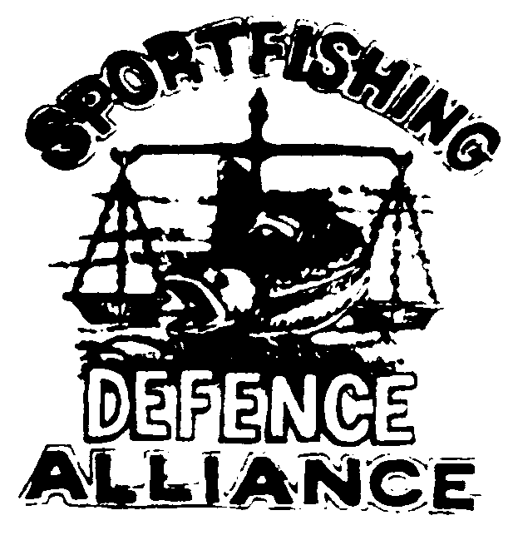
SPORTFISHING
DEFENCE

ALLIANCE
P.O. Box 2477
CHILLIWACK, BC. V2R 1A8
Ph. (250) 378-4489
Fax. (250) 378-4489

December 13, 2005

Honourable Geoff Regan, Minister
Fisheries and Oceans Canada
House of Commons,
Ottawa, Ontario.
K1A 0E6

Dear Mr. Minister:

We write this letter to you in light of the fact that the Federal Government websites dealing with the proposed listing of the Interior Fraser Coho is so convoluted you cannot find whom specifically to address your comments to.

I did a search for Upper Fraser Coho on the Gazette website and got an extensive listing of the addresses of the branches for the Royal Bank, Toronto Dominion Bank, CBIC, Bank of Nova Scotia etc. etc. Not what I would call helpful in finding the information to respond to your proposal for a SARA “endangered” listing for Upper Fraser/Thompson Coho.

I trust you will forward our comments on to whoever is supposed to deal with them. I have taken the liberty of copying our members and others concerned to ensure there is a full understanding of the travesty your government is attempting to inflict on the people of British Columbia through this listing.

We would advise that given the fact of the Christmas season and a Federal election the 30 day response time is inadequate.

That said, it is obvious you and your government intend to proceed regardless of the consequences so we offer the following.

First and foremost, we wish to advise you that the membership of the Sportfishing Defence Alliance (SDA) is absolutely opposed to the listing of Interior Fraser Coho as “endangered” under SARA at this time.

We offer the following as rationale for bringing a halt to this current farce.

1 – Failure to provide information in the “Proposed Recovery Strategy” in a timely and meaningful fashion.

While the recreational sector had some input to the original draft of this document, they were not included in the final draft and in fact were never given a copy until less than two weeks ago.

The commercial fishing sector was not ever involved in the process and was never given any input at all into this document and the plans.

The so-called consultation process held last year was a total farce. The process dealt with five or six species and proposals for Rockfish Protection Areas. The draft documents dealing with Fraser Coho, Sakinaw Sockeye and Cultus Sockeye all exceeded 100 pages and were not provided to the public prior to the meetings other than an electronic format. This format of course was not possible to bring to the meetings. In addition no copies were made available at the meetings.

I went to two sessions specifically to discuss concerns over the Fraser Coho and no opportunity was provided. Those of us present got a dog and pony show from the U.S. consultant supposedly facilitating the process but no opportunity for input. In short Minister, your so called consultation outlined in the Regulatory Impact Assessment Statement (RIAS) is and was badly flawed and in no way can this be identified as meaningful or reasonable consultation by any definition of the word.

Also as previously noted, we in the public have had a copy of the “Proposed Recovery Strategy” for less than two weeks, with a very few lucky enough to get a copy. Your Pacific Region staff in fact sent out an e mail as late as yesterday advising that the report was available and would be sent out on request. This was December 12th, given Christmas mail problems perhaps anyone requesting this document might have it by January 9th but one should not count on that. Not that it matters anyway as we have been told by your Pacific Region senior staff that it has yet to be vetted by the Pacific Region staff and is not yet a final report. In addition we are told that Ottawa has not even seen this document. Given those facts Mr. Minister, we would be pleased to hear on what basis you made your decision to recommend listing the Interior Fraser Coho as “endangered”.

2 – The economic impact statement as authorized by yourself is no where near complete and is but a cursory document. Given the fact even this level of documentation indicates the listing of these fish could result in an economic loss to B.C. of over $200 million annually begs the question. Why did you not carry our a full and complete economic impact so as to allow for a “reasoned” judgment on the issue?

Moreover, the conclusions of the flawed economic assessment you authorized, are predicated on there being no change in the current regulations around Interior Fraser Coho. Minister, no one has given assurance that such will be the case; in fact for the most part your Pacific Region has not even addressed this issue.

The simple fact remains that with the listing of this stock, if your government plans to have any recreational, commercial or first nations fishing continue in Southern British Columbia, then you must issue at least 500,000 permits to allow “harm” to Interior Fraser Coho. We cannot wait to hear your government’s rationale for the issuance of this many permits to “harm” an “endangered” species.

3 – Your government refused to list as “endangered” either Sakinaw Sockeye or Cultus Lake Sockeye which had returning adult numbers of 3 fish and 200 or less fish. Not only that but you did not even move to recommend these fish be listed at a lower level of concern. The total refusal of your government to list these stocks at any level sends the message that you have no concern at all for the future of these fish.

At the same time, you are moving swiftly to now list as “endangered” a stock that has shown in recent years returns continuously over 20,000 fish and in excess of 50,000 fish in some instances.

The rationale of your government for the incongruity of these decisions would be much appreciated.

And finally Mr. Minister, the most telling reason:

4 – Science does not support such a listing!

The fact remains Minister that when the matter of the Interior Fraser Coho was first referred to COSEWIC for consideration, they in turn gave it to their scientific panel/committee, for fisheries. This august panel, made up of scientists from all parts of Canada, reviewed the evidence regarding Interior Fraser Coho with a view to some form of listing under the SARA designations.

Minister, this panel of some of the best fisheries scientific minds in Canada could not garner one single vote to list this stock as “endangered”. That is correct Mr. Minister NOT ONE SINGLE VOTE FOR AN “ENDANGERED” LISTING!

The panel was split between listing the stock as either “a stock of concern” or “threatened”.

The decision by COSEWIC to list as “endangered” was a political decision and not one based on science. Even your own Pacific Region staff cannot come up with a rational reason for listing this stocks Minister, they simply parrot the COSEWIC decision.

It is the understanding of our members that listings under SARA are supposed to be made on scientific information and not on political expediency.

We ask that you and your government return this process to a respectable scientific one and deny the continuation of a political decision and refuse to list the Interior Fraser Coho as “endangered” under SARA.

Bill Otway, President
Sportfishing Defence Alliance.

Cc – All MP’s
CC – All MLA’s
Cc – Members of the Media
Cc – Concerned citizens.

.

