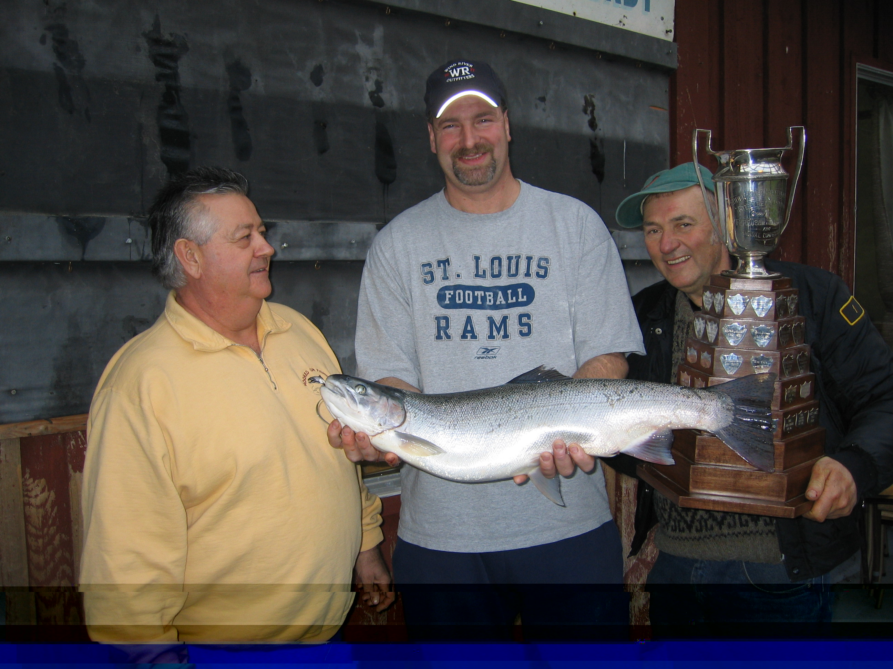
The King Fish 2004

Derby Winners, December 26, 2004

Heaviest Fish 12.44 pounds by Ken Bergman

First Fish shortly after 8:00 am by Brian Tomicki

2nd Heaviest Fish 12.41 pounds by Donald Kozak

3rd Heaviest Fish 12.17 pounds by Marty Moore

4th Heaviest Fish 12.13 pounds by Ernie McDuff

5th Heaviest Fish 11.62 pounds by Edward Riel

Smallest Steelhead 6.70 pounds by Bruce Bishop

Hidden Weight Fish 10.6 pounds by Mark Wong

Other Fish Weighed In:
8.84 pounds by Peter Glover
7.80 pounds by Brandon Wootton

Boxing Day

Steelhead Derby

Rules

The Chilliwack Fish and Game
Protective Association

